Proceedings of the
Sixty-Sixth Annual Convention
Alabama State Chapter
P.E.O. Sisterhood


Organized January 8, 1959
Auburn, Alabama


HOSTESS CHAPTERS
F, I, N, AI, and AF

Hotel Capstone
Tuscaloosa, AL

April 25-26, 2025

TABLE OF CONTENTS

CONVENTION DOCUMENTS
Rules Of Convention 1
Founders Of P.E.O. 2
Representative Of International Chapter 2
Officers Of International Chapter 2
Officers Of Alabama State Chapter 2
Alabama Chapters 2
Past Presidents Of Alabama State Chapter 3
Standing Committees And Appointments 4
Convention Responsibilities And Committees 5
Convention Committee Chairs 6
Members Of Convention 7
Local Chapter Delegates 8
Credentials Report Form 9
Pre-Convention Program 10
Convention Schedule 10
“O, Canada” and “The Star-Spangled Banner” 13
Minutes Of Convention 14
Executive Board Annual Reports 22
Convention Correspondence 29

ALABAMA STATE CHAPTER ANNUAL REPORTS TO INTERNATIONAL
2024-2025 Annual Dues Form for State 30
2024-2025 Annual Report of Membership 31

FINANCIAL DOCUMENTS
Summary of Receipts and Expenditures by Funds 32
Total Chapter Giving to P.E.O. Projects 32
General Fund Budget 33
Convention Budget 34
Report of Audit Committee 35
Alabama State Chapter Gift Log 36

STATE PHILANTHROPY COMMITTEE REPORTS 43

OTHER REPORTS
Membership 49
Nominating Committee 50
Finance Committee 50
Historian 51

CERTIFICATION OF MINUTES AND APPROVAL OF PROCEEDINGS 53

2025 NOMINEE TO THE ALABAMA STATE BOARD 54

PROPOSED AMENDMENTS TO THE BYLAWS AND STANDING RULES OF ALABAMA STATE CHAPTER 55

INTERNATIONAL REPRESENTATIVE 56

2025 PHILANTHROPY SPEAKERS 57

ADDITIONAL INFORMATION
2025 Milestone Birthday Chapters 60
2025 Silver Sisters 61
2025 Golden Girls 61
Celebration of Life 62
President’s Opening Remarks 63
Outgoing President’s Closing Remarks 63
Incoming President’s Remarks 65
Convention Devotion 67

PAST PRESIDENTS OF ALABAMA STATE CHAPTER 68

INCOMING PRESIDENT’S THEME 70

2025-2026 ALABAMA STATE CHAPTER OFFICERS AND STATE COMMITTEES 70

2025-2026 ALABAMA STATE CHAPTER GOALS 74

ALABAMA STATE CHAPTER BYLAWS AND STANDING RULES B-1



RULES OF CONVENTION

Admission:
- Delegates and visitors must register before attending convention business meetings.
- Admission to business meetings of convention shall be gained by showing convention badge.

General:
- Members are requested to be in their seats for the call to order.
- Members should remain seated for the processional and the recessional.
- No photos or videos, including live streaming, shall be taken during a business meeting. All electronic devices (e.g., tablets, laptops, cell phones) shall not be used during meetings. Exception: The state secretary may use a laptop for her assigned duties.
- Cell phones should be placed on silent mode.
- Messages shall be given to and delivered by convention assistants/tellers/pages/guards except during speeches or musical presentations.
- Inability to hear shall be signified by raising the hand.
- A committee appointed by the president has the responsibility to read and approve the minutes of convention.
- Addresses, remarks, and answers to questions given by the representative of International Chapter shall not be recorded, duplicated, or distributed.

Speaking and Voting:
- Only voting members of convention are allowed to speak and vote on a subject.
- A member addressing the presiding officer shall give her name and chapter letter(s) before being recognized.
- When speaking to an amendment, no member shall speak more than once and for more than one (1) minute. Total time on a proposed amendment shall be limited to seven (7) minutes. The speaker will use a floor microphone.
- Amendments adopted at convention will take effect at the close of convention or as instructed in state bylaw.

Founders of P.E.O.
Mary Allen (Stafford) 1848 - 1927
Alice Bird (Babb) 1850 - 1926
Hattie Briggs (Bousquet) 1849 - 1877
Alice Virginia Coffin 1848 - 1888
Suela Pearson (Penfield) 1851 - 1920
Franc Roads (Elliott) 1852 - 1924
Ella Stewart 1848 - 1894

Representative Of International Chapter
Beverly Prewitt, Chair
Chair, P.E.O. Program for Continuing Education Board of Trustees

Officers of International Chapter
President... ......Cathy Moss
First Vice President Alix Smith
Second Vice President Kathryn Ebert
Organizer Jennifer Mitchell
Recording Secretary Kathryn Bayne

Officers of Alabama State chapter
President Elaine Bassett Troy, AF
Vice President Cel Bailey Birmingham, D
Organizer Paige McCormick Tuscaloosa, AC
Treasurer Nancy Newton Huntsville, AJ
Secretary Cheryl Williams Foley, AG

Alabama Chapters

Chapter A Auburn

Chapter B Birmingham

Chapter C Mobile

Chapter D Birmingham

Chapter E Auburn

Chapter F Birmingham

Chapter G Montgomery

Chapter H Mobile

Chapter I Tuscaloosa

Chapter J Huntsville

Chapter K Montgomery

Chapter L Mobile

Chapter M Huntsville

Chapter N............Tuscaloosa

Chapter O Montgomery

Chapter P Birmingham

Chapter Q Decatur

Chapter R Tuscaloosa

Chapter S Florence

Chapter T Birmingham

Chapter U Decatur

Chapter V Ozark

Chapter W Dothan

Chapter X Auburn

Chapter Y. Montgomery

Chapter Z Madison

Chapter AA Birmingham

Chapter AB Daphne

Chapter AC Tuscaloosa

Chapter AD Huntsville

Chapter AE Anniston

Chapter AF Troy

Chapter AG Foley

Chapter AH Dothan

Chapter AI Prattville

Chapter AJ Huntsville

Chapter AK Birmingham

Chapter AL Madison

Chapter AM Birmingham

Chapter AN Florence

Chapter AO........Montevallo

Chapter AP.............Gadsden

Past Presidents of Alabama State Chapter
* Chapter Eternal
** Died in office 1967

*Harriette Chadwick, A 1959-1960
*Maurine Evans, B 1960-1961
*John Fleming, C 1961-1962
*Joyous Mahaffey, A/CO 1962-1963
*Lisa Davis, X 1963-1964
*Isabel Palmer, F 1964-1965
*Inez Sickels, D 1965-1966
*Sarah F. McPhearson, B 1966-1967
**Alice Schreiber, A 1967-1968
*June Williams, H 1967-1968
*Inez Bartlett, D 1968-1969
*Ginny Douglass, J 1969-1970
*Thelma C. Wilkins, N 1970-1971
*Catherine Segars, C 1971-1972
*Betty C. Harrison, AD 1972-1973
*Ann Bennett, O 1973-1974
*Fyrn Watkins-Wesson, AA 1974-1975
*Margie Hudson, K 1975-1976
*Maury Ferguson, C 1976-1977
*Amelia Lawley, G 1977-1978
*Winifred Boyd, A 1978-1979
Margaret Shoemaker, T 1979-1980
Sylvia Hellums, I 1980-1981
*Sara Ann Curry, A 1981-1982
*Dean Hays-Elam, E 1982-1983
*Jeanette Self, U 1983-1984
*Elmira Alison, K 1984-1985
*Frances Corwin, G 1985-1986
Lauren Watson, BC/FL 1986-1987
*Kathryn Remaley, R 1987-1988
*Jerry Odle, P 1988-1989
*Shirley Beckett, IR/IA 1989-1990
*Margaret Peacock, K 1992-1993
Nancy McFeters, JL/WA 1993-1994
Sheila Morgan, AM 1994-1995
*Marianne Stevens, J 1995-1996
Marilyn Mancini, AC 1996-1997
Patricia Franklin, G 1997-1998
Karla Gniadek, M 1998-1999
Mary Donald, Y 1999-2000
Dani Halverson, E 2000-2001
Debra Cunningham, Y 2001-2002
*Carol Timkovich, R 2002-2003
Bette C. Bryan, W 2003-2004
Betty von Herrmann, AA 2004-2005
Susan Santoli, CK/NC 2005-2006
Rebecca Drennen, G 2006-2007
*Sally Sorocak, H 2007-2008
Gayle Howell, AC 2008-2009
Mary G. Wiley, AJ 2009-2010

Holly Fondots, T 2010-2011
Patty Piro, AL 2011-2012
Carol Westbrook, D 2012-2013
Grace Anderson, U... ……………2013-2014
Betty Smith, V…………………...2014-2015
Nancy Sites Sizemore, AG 2015-2016
Shirley Paramore, V 2016-2017
Rebecca Reardon, AM 2017-2018
*Elizabeth (Lisa) Sallo, AL 2018-2019
Janice Alcorn, AN 2019-2020
Linda Wilkins Kottmeyer, AM 2020-2021
Denise Williams, U……………...2021-2022
Wendy James, AP.........................2022-2023
Cindy Fry, AD 2023-2024

*Frances Mullen.....................................1990-1991
*Carolyn Jordan, AA 1991-1992

Standing Committees And Appointments

Amendments and Recommendations Committee
Gayle Howell, PSP, AC, Chair
Carol Fischer, T
Sonya Leeds, AH

Auditing Committee
Cindy Fry, PSP, AD, Chair
Linda Roden, J
Sally Priester, AD

Finance Committee
Susan Richardson, C, Chair
Julia Naefe, AL
Carol Sue Lewis, G
Betty Smith, PSP, V

Membership Committee
Paige McCormick, AC, Organizer, Adviser
Luann Rice, C, Chair
Lisa Vardaman, AF
Karen Sargent, AL
Merrily Newton, AM

Nominating Committee
Elaine Bassett, AF, President, Liaison
Wendy James, PSP, AP, Chair
Shelly Salmon, AE
Judy Weaver, C

Celebration Of Life
Cindy Fry, PSP, AD
Jenn Sherrill, N
Jennie Oliver, J

Alabama Cottey College Scholarship
and Recruitment Committee
Cel Bailey, D, Vice President, Adviser
Sarah Gilbert, Q, Chair
Susan Tanner, S
Cynthia Lumpkin, AH

P.E.O. Educational Loan Fund Committee
Nancy Newton, AJ, Treasurer, Adviser
Beth Beck, Z, Chair
Dawn Daly, E

P.E.O. International Peace Scholarship Committee
Chery Williams, AG, Secretary, Adviser
Carol Williams, L, Chair
Judy Wesson, L

P.E.O. Program for Continuing Education Committee
Nancy Newton, AJ, Treasurer, Adviser
Valerie Cox, AL, Chair
Janice Candler, Y

P.E.O. Scholar Awards Committee
Chery Williams, AG, Secretary, Adviser
Terry Corley, L, Chair
Jane Searcy, R

P.E.O. STAR Scholarship Committee
Paige McCormick, AC, Organizer, Adviser
Dee Dee Given, D, Chair
Mandy McKenzie, AO

Historian
Lisa Vardaman, AF

Convention Responsibilities and Committees

Advisor to Guards, Pages and Tellers
Mary Wiley, PSP, AJ

Convention Pages/Tellers

Debbie Hobbs, X

Cathy Long, X

Guards
Mellie Bassett, AF, co-head guard
Katie Temple, AF, co-head guard
Rita Doughty, AC
Connie Grechanik, AC
Carol Sue Lewis, G
Misty Moon, AC
Mame Morgenstern, G
Barbara Nicol, AC

PARLIAMENTARIAN

Beverly Prewit, chair
P.E.O. Program for Continuing Education Board of Trustees

Credentials Committee
Denise Williams, PSP, U
Cindy Harris, I
Darlene Collins, I

Committee to Approve Minutes
Sheila Morgan, PSP, AM
Terry Corley, L
Nancy Sizemore, PSP, AG

Convention Steering Committee

Shellyn Poole, F, Chair
All members of Chapters F, I, N, AF, and AI

Convention Committee Chairs

Audit Committee…………………………………………………………………………Katie Temple, AF
AV................................................................Martha Hocutt, I; Lisa Vardaman, AF; Shellye Vardaman, AF
BIL Activities................................................................................................................Cathy Wooldridge, N
Call to Convention................................Jennie Oliver, J; Cindy Harris, I; Amy Howser, F; Shellyn Poole, F
Celebration of Life.................................................................................. ...Jenn Sherrill, N; Jennie Oliver, J
Convention Kits....................................................................................Kathy Graham, F; Margaret Balch, F
Daisy Garden.............................................Mellie Bassett, AF; Lisa Vardaman, AF; Shellye Vardaman, AF
Decorations/Favors................................................................................. Cathy Wooldridge, N; Jan Mize, N
Entertainment............................................................................................................... Cathy Wooldridge, N
First Aid.......................................................................................... Lynn Ireland, N; Shellye Vardaman, AF
Guards/Pages......................................... ............................................Katie Temple, AF; Mellie Bassett, AF
Hospitality Room/Refreshments.......................................................... Kathy Graham, F; Margaret Balch, F
Invitation to Convention..........................................................................Jan Mize, N; Cathy Wooldridge, N
Meals............................................................................................................ Sandy Kelser, AI; Pat Cone, AI
Music.............................................................................................................................. . . ....Cindy Harris, I Name Badges/Tags...................................................................................Cindy Harris, I; Darlene Collins, I
Publicity.............................................................................................................Chapters F, I, N, AF, and AI
Properties ............................................................................................................................ ..Lynn Ireland, N
Registration ..............................................................................................Cindy Harris, I; Darlene Collins, I
Signage.....................................................................................................Jan Mize, N; Cathy Wooldridge, N
Sponsors.............................................................................................................................. Shellyn Poole, F
Treasurer.................................................................................................................................Amy Howser, F
Volunteer Coordinator.......................................................................................................... Shellyn Poole, F

Members of Convention

Executive Board

President Elaine Bassett, AF
Vice President Cel Bailey, D
Organizer Paige McCormick, AC
Treasurer Nancy Newton, AJ
Secretary Cheryl Williams, AG

Past State Presidents

Margaret Shoemaker, T
Sheila Morgan, AM
Marilyn Mancini, AC
Mary Donald, Y
Elizabeth “Betty” von Herrmann, AA
Gayle Howell, AC
Mary Wiley, AJ
Carol Westbrook, D
Betty Smith, V
Nancy Sites Sizemore, AG
Rebecca Reardon, AM
Linda Kottmeyer, AM
Denise Williams, U
Wendy James, AP
Cindy Fry, AD

State Committee Chairs

Finance Susan Richardson, C
Membership Luann Rice, C
ACCSRC Sarah Gilbert, Q
IPS Carol Williams, L
PCE Valerie Cox, AL
PSA Terry Corley, L
STAR Dee Dee Given, D
Historian Lisa Vardaman, AF

Local Chapter Delegates

Chapter A
Auburn

Chapter B  Birmingham | Diana Shepherd  Nancy Spangler
Chapter C  Mobile | Dale Hair  Ann Holston
Chapter D  Birmingham | Linda Butler  Julie White
Chapter E  Auburn | Charlotte Hoerlein  Tori Ninde
Chapter F  Birmingham | Ann Birchall  Jane Cole
Chapter G  Montgomery | Alicia Bozeman  Dianne Corwin
Chapter H  Mobile | Brenda Humphreys  Katherine Penton
Chapter I  Tuscaloosa | Alicia Lee  Julia Stewart
Chapter J  Huntsville | Linda Roden  Marian Woerner
Chapter K  Montgomery | Elizabeth Harber  Debra Laughlin
Chapter L  Mobile | Marcia Jacobs  Holly Vinson
Chapter M  Huntsville | Nancy Franks  Karla Gniadek
Chapter N  Tuscaloosa | Carol Hoffman  Susanne Nasir
Chapter O  Montgomery | Anne Parramore  Kathy Smith
Chapter P  Birmingham | Virginia (Ginny) Aday  Kathy Brown
Chapter Q  Decatur | Debbie Gardner  Jackie Naumann
Chapter R  Tuscaloosa | Susan Benke  Dana Templeton
Chapter S  Florence | Frances Quick  Susan Tanner
Chapter T  Birmingham | Micheline Parkey  Mary Porter
Chapter U  Decatur | Grace Anderson  Rebecca Rieniets
Chapter V  Ozark | Judie Holloway  Thresia Peak
Chapter W  Dothan | Sherri Boyette  Mary Calhoun
Chapter X  Auburn | Starling Grisham  Amy McAllister
Chapter Y  Montgomery | Fiona Capel  Linda Long
Chapter Z  Madison | Beth Beck  Leslee Garza
Chapter AA  Birmingham | Laura Carr  Ruth Stopak
Chapter AB  Daphne | Kathleen Peters  Carolyn Sawyer
Chapter AC  Tuscaloosa | Linda Cain  Brenda Lyons
Chapter AD  Huntsville | Luci Black  Sally Priester
Chapter AE  Anniston | Pamela Johnson  Linda Nichols
Chapter AF  Troy | Teri Williams  Edith Smith
Chapter AG  Foley | Kelli Weaver  Nancy Sizemore
Chapter AH  Dothan | Diane Howse  Sonya Leeds
Chapter AI  Prattville | Margery Fallen  Patsy Nickerson
Chapter AJ  Huntsville | Patti Fitzgerald  Becky Wheatley
Chapter AK  Birmingham | Pete Partin  Georgia Raby
Chapter AL  Madison | Ginny Aldridge  Linda Peirce
Chapter AM Birmingham | Ginny Hart  Merrily Newton
Chapter AN  Florence | Janice Curtis  Melissa Voorhies
Chapter AO  Montevallo | Sylvia Sheffield  Mavis Smith
Chapter AP  Gadsden | Nikki Major  Kim Moss

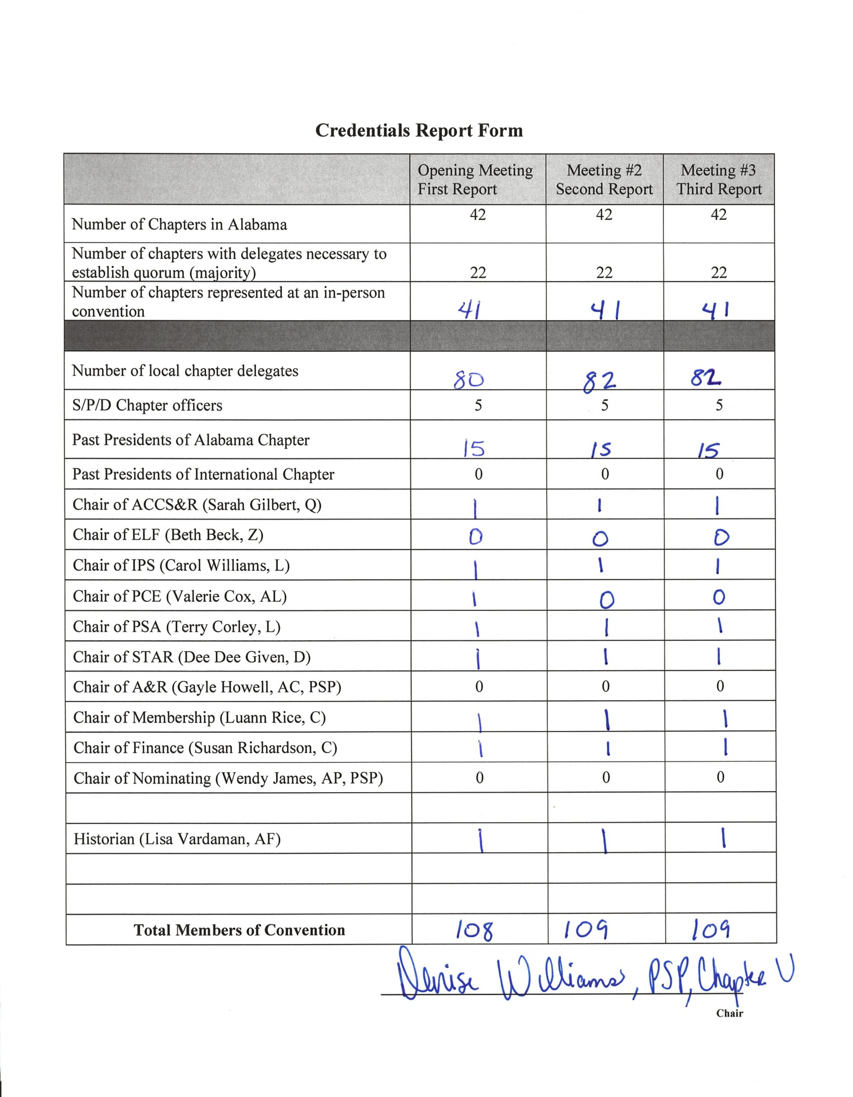

Pre-Convention Program
Thursday, April 24, 2025
9:00 – 11:30 Executive Board Meeting President’s Room
11:30 – 12:30 Executive Board Lunch President’s Room
12:30 – 3:30 Executive Board Meets with International Representative President’s Room
3:30 – 4:30 International Representative Meets with Past State Presidents Ballroom D
3:30 – 4:30 Executive Board Hotel Walk-through
4:30 – 7:00 Hospitality Room Open
5:00 – 6:30 Daisy Garden Moore Room
5:15 – 6:00 Past State Presidents Cocktails Pre-Function Area Outside Governor’s Room
(Cash Bar Available at Legend’s)
6:00 – 8:00 Past State Presidents Dinner Governor’s Room

Friday Morning, April 25, 2025

7 – 11 Hospitality Room open
8 – 5 Registration Open Registration Desk
8 – 11 Daisy Garden open Moore Room
8 – 5 Project Displays Outside Ballrooms
10 – 11 Celebration of Life Ballrooms A through D
11:15 – 11:30 Registration Review with IR Registration Desk
11:30 – 11:45 Guards and Pages meeting Back of Ballroom A
11:30 – 11:45 Committee to Approve Minutes meeting Back of Ballroom C
11:45 – 12:00 Delegates Orientation Ballroom B
12:00 – 1:00 Box Lunch Outside Ballrooms
1:00 Guards in Place

Convention Schedule

Friday, April 26, 2024
Elaine Bassett, presiding

1:15 Prelude Ballrooms
Processional (Please remain seated) Ballrooms
1:30 Call to Order Elaine Bassett, AF
Invocation Cindy Fry, PSP, AD
Pledge of Allegiance Debbie Gardener, Q; Jackie Nauman, Q
“O Canada” and “The Star Spangled Banner” Led by LuAnn Rice, C
Welcome and President’s Greeting Elaine Bassett, AF
Report of the Guards Katie Temple, AF, and Mellie Bassett, AF
Report of Credentials Committee Denise Williams
Formal Opening of Convention Business Elaine Bassett, AF
Opening Ode Linda Kottmeyer, PSP, AM
Objects and Aims Linda Kottmeyer, PSP, AM
Devotion Sally Priester, AD

Introductions

Representative of International Chapter Elaine Bassett

Beverly Prewitt, Chair
P.E.O. Program for Continuing Education Board of Trustees

Past State Presidents Nancy Sizemore, PSP, AG
Executive Board Elaine Bassett
Guards and Pages Elaine Bassett
Welcome from the Convention Chair Shellyn Poole
Response by Secretary Cheryl Williams
Adoption of Rules of Convention Cheryl Williams
Adoption of Program Cheryl Williams Appointment of Committee to Approve Minutes Elaine Bassett
Appointment of Parliamentarian Elaine Bassett

Keynote by Representative of International Chapter Beverly Prewitt

Reports
Officers Elaine Bassett
Committees Elaine Bassett
Historian Lisa Vardaman
Nominations and Elections of Officers Wendy James
Finance and Adoption of Budget Susan Richardson
Amendments and Recommendations Gayle Howell

Workshop #1 Jeopardy! Paige McCormick and Cel Bailey

Announcements Shellyn Poole

Adjourn

Friday Evening, April 26, 2025

5:30 – 6:30 President’s Reception (cash bars available) Outside Ballrooms
6:30 – 8:30 Friends and Family Banquet Ballrooms A through D
Welcoming Remarks Elaine Bassett
Blessing Elaine Bassett
Remarks by International Representative Beverly Prewitt
Entertainment

Saturday Morning, April 27, 2025

7 – 9 Hospitality Room Open
8 – 11 Daisy Garden Open Moore Room
8 – 5 Registration Open Registration Desk
8 – 5 Project Displays Outside Ballrooms

8:30 Guards in Place
8:30 Prelude
8:45 Call to Order Elaine Bassett
Report of the Guards Katie Temple and Mellie Bassett
Second Report of Credentials Denise Williams
Election of Delegates to Convention of International Chapter Elaine Bassett
Celebrations! Golden Girls and Chapter Birthdays Cheryl Williams

Period of Instruction, “Leading Efficient Chapter Meetings” Paige McCormick
Project Chairs and Speakers Cel Bailey

Announcements Shellyn Poole
Blessing for Lunch Elaine Bassett

11:30 Lunch Buffett (BILs and other Guests are welcome)
11:45—1:00 Daisy Garden Open Moore Room

Saturday Afternoon, April 27, 2025

12:45 Guards in Place
Prelude
1:00 Call to Order Elaine Bassett Report of Guards Katie Temple and Mellie Bassett Final Report of Credentials Denise Williams
Local Chapter Goals Elaine Bassett

Workshop #2 Membership: The Heart of P.E.O. Membership Committee

Hostess Chapter Recognition Elaine Bassett

Guards Admit Guests

Welcome of Special Guests Elaine Bassett
Remarks by Outgoing President Elaine Bassett
Installation of Officers Beverly Prewitt
Special Presentations Cel Bailey
Presentation of Credentials Beverly Prewitt
Remarks by Newly Installed President Cel Bailey
Introduction of Guests Cel Bailey
Invitation to 2026 67th Annual Convention Chapters J, T, Z, and AN
Acceptance of Invitation Cel Bailey
Closing Remarks of Representative of International Chapter Beverly Prewitt
Report of Visitors and Announcements Cindy Harris and Shellyn Poole
Unfinished Business Cel Bailey
Committee Appointments Cel Bailey
Announcements Shellyn Poole
Formal Close of Convention Cel Bailey

**********************************************************************

O, Canada

O, Canada! Our home and native land!
True patriot love in all of us command.
With glowing hearts we see thee rise,
The True North strong and free!
From far and wide, O Canada, we stand on guard for thee.
God keep our land glorious and free!
O Canada, we stand on guard for thee.
O Canada, we stand on guard for thee.

The Star Spangled Banner

Oh, say, can you see, by the dawn’s early light,
What so proudly we hailed at the twilight’s last gleaming.
Whose broad stripes and bright stars, through the perilous fight,
O’er the ramparts we watched, were so gallantly streaming.
And the rockets’ red glare, the bombs bursting in air,
Gave proof through the night that our flag was still there.
Oh, say, does that Star Spangled Banner yet wave
O’er the land of the free, and the home of the brave.

MINUTES OF CONVENTION

OPENING MEETING
Friday Afternoon, April 25, 202

The 66th Annual Convention of the Alabama State Chapter of the P.E.O. Sisterhood convened at 1:20 p.m., Friday, April 25, 2025, at the Hotel Capstone in Tuscaloosa, Alabama. Chapters F, I, N, AI, and AF served as hostess.
“Sisters, Sisters” was played during the processional for the executive board, Representative of International Chapter, and past state presidents.
The meeting was called to order by President Elaine Bassett at 1:20 p.m.
Cindy Fry, PSP, Chapter AD, delivered the invocation.
Debbie Gardener and Jackie Nauman, both from Chapter Q, led the Pledge of Allegiance, after which LuAnn Rice, Chapter C, led the singing of “O Canada” and “The Star-Spangled Banner.”
President Elaine Bassett welcomed all attendees on behalf of the Executive Board of Alabama State Chapter.
The assistant guards took their places and Head Guards Katie Temple and Mellie Bassett, both from Chapter AF, gave the report of the guards.
The president introduced the guards after their report.
The first report of the Credentials Committee was given by the chair, Denise Williams, PSP, Chapter U. Chair Denise Williams reported 108 members of convention entitled to vote. On behalf of the committee, the chair moved the report be adopted. There being a majority in the affirmative, the report was adopted. (Proceedings, p. 9)
Cheryl Williams, secretary, moved that the Rules of Convention, as printed in the program, be adopted. The motion was seconded and adopted.
Cheryl Williams, secretary, moved the adoption of the printed program with necessary changes. The motion was seconded and adopted, as corrected.
A quorum being established, the president declared the 66th Convention of Alabama State Chapter opened in due form and ready for the transaction of business.
Linda Kottmeyer, PSP, Chapter AM, led the singing of the Opening Ode, followed by the reciting of the Objects and Aims.
Sally Priester, Chapter AD, gave the devotion.

President Elaine Bassett introduced and welcomed Beverly Prewitt as the Representative of International Chapter. Beverly Prewitt is a member of Chapter DP/OH, past president of Virginia State Chapter, and currently serves as chair of the P.E.O. Program for Continuing Education Board of Trustees of International Chapter.
Nancy Sites Sizemore, PSP, Chapter AG, representative of the past presidents, introduced the 18 past presidents in attendance.
Secretary Cheryl Williams was asked to send greetings and love to all past presidents who were unable to attend the convention.
The members of the Committee to Approve Minutes were authorized by the Rules of Convention. The president introduced Shelia Morgan, PSP, Chapter AM; Terry Corley, Chapter L; Linda Kottmeyer, PSP, Chapter AM, and thanked the committee for assisting the secretary.
The president announced that Beverly Prewitt, Representative of International Chapter, would serve as parliamentarian.
Cheryl Williams, secretary, read a letter from Cathy Moss, president of International Chapter of the P.E.O. Sisterhood.
Following the introduction by President Elaine Bassett, the Representative of International Chapter, Beverly Prewitt, presented the keynote address titled “Hope for the Journey.”
The president thanked her for her inspiring message.
The President announced that the annual reports of state officers and state committees were included in the convention program for all to read and will be incorporated in the proceedings of this convention. (Proceedings, pp. 22-28, 43-52.)
State Historian, Lisa Vardaman, Chapter AF, presented the state's history for the year. President Elaine Bassett reminded all attendees to visit the historian’s display.
The report of the Nominating Committee was given by the chair, Wendy James, PSP, Chapter AP, who first introduced the other committee members: Shelly Salmon, Chapter AE, and Judy Weaver, Chapter C. The Nominating Committee presented their report and the following slate of officers for the 2025-2026:
President.........................................Cel Bailey, Chapter D
Vice President.................................Paige McCormick, Chapter AC
Organizer........................................Nancy Newton, Chapter AJ
Treasurer........................................Cheryl Williams, Chapter AG
Secretary........................................Sally Priester, Chapter AD
The president thanked the committee for its work.
The next order of business was election of officers.
There being no further nominations from the floor, the nominations were declared closed. There being no objection, the written ballot was dispensed with and a voice vote taken. Election of officers was completed and the following members declared elected as officers of Alabama State Chapter for the ensuing year:
President: Cel Bailey
Vice President: Paige Mc Cormick
Organizer: Nancy Newton
Treasurer: Cheryl Williams
Secretary: Sally Priester
The president announced that the installation of new officers would take place during the third meeting on Saturday, the 26th.
President Elaine Bassett called attention to the copy of the budgets provided to each member of convention. (Proceedings, pp.33-34.) She introduced the Finance Committee chair Susan Richardson, Chapter C, who introduced the other members of her committee: Julia Naefe, Chapter AL; Carol Sue Lewis, Chapter G; Betty Smith, PSP, Chapter V. The chair presented the committee’s report, including information regarding review of accounts, preparation of budgets, and recommendation for surplus funds.
The chair moved the adoption of the report. By general consent, the vote was divided into three parts and a majority voted in favor of each of the following:
- Adoption of the budgets, as amended.
- Transfer of funds: $6,000 from the General Fund to the Convention Fund
- The remainder of the report.
The President stated that the adoption of the report approved the report of the treasurer.
The president thanked the members of the Finance Committee for watching the state finances during the year. She announced the audit report for 2025 is posted on the state website and will be included in the convention proceedings. (Proceedings, p. 35.)
In preparation for the presentation of amendments to the Bylaws and Standing Rules of Alabama State Chapter, the president requested all members of convention to be in their assigned seats. She instructed the convention in the procedure for presentation of amendments and voting. In accordance with the Rules of Convention, amendments adopted would take effect at the close of convention as specified in the Bylaws and Standing Rules of Alabama State Chapter.
The report of the Amendments and Recommendations (A&R) Committee was given by the chair, Gayle Howell, PSP, Chapter AC. The chair introduced the members of her committee: Carol Fisher, Chapter T, and Sonya Leeds, Chapter AH.

The chair presented the 2025 proposed amendments to the Bylaws of Alabama State Chapter. Page numbers refer to the 2024 Bylaws and Standing Rules of the Alabama State Chapter.

- Submitted by the Executive Board of Alabama State Chapter and the Finance Committee of Alabama State Chapter
(page B-6) Amend ARTICLE VI, Section 2, paragraph 2, item 2, sentence 1, by striking out the word “prepare” and inserting the words “coordinate with the executive board in preparing” so that if adopted it will read:
To coordinate with the executive board in preparing a budget for the state chapter for the ensuing year, and to present this budget for consideration at convention of the state chapter. A copy of this budget shall be placed in the kits of members of convention.
The amendment was adopted by a two-thirds vote.

- Submitted by the Executive Board of Alabama State Chapter
(page B-8) Amend ARTICLE VIII, Section 2, sentence 2, by inserting the words “or reorganized” following the words “a new” so if adopted it will read:
Section 2 – OFFICIAL VISITS TO LOCAL CHAPTERS. Official visits by the organizer shall be quinquennial. However, a new or reorganized chapter shall be visited annually for the first three years. Any chapter may be visited…
The amendment was adopted by a two-thirds vote.

At the direction of the A&R Committee, the A&R chair moved the adoption of the following editorial resolution:
Resolved, That the 2025-2036 Executive Board of Alabama State Chapter be authorized to correct article and section designations, punctuation and cross-references and to make such other technical and conforming changes as may be necessary to reflect the intent of Alabama State Chapter.
The editorial resolution was adopted.
The president thanked the members of the committee for their work.

Vice President Cel Bailey and Paige McCormick led an educational version of “P.E.O. Jeopardy.”

Announcements were made by Convention Chair Shellyn Poole.
The president declared the convention adjourned until Saturday, 8:30 a.m.

ADJOURNMENT

SECOND MEETING
Saturday, April 26, 2025

President Elaine Bassett called the second meeting of the 66th Convention of Alabama State Chapter to order at 8:50 a.m.
The assistant guards took their places and the head guards, Mellie Bassett and Katie Temple, gave the report of the guards.
The second report of the Credentials Committee was given by the chair, Denise Williams, PSP. One hundred nine members of convention were reported. On behalf of the committee, Denise Williams moved the report be adopted. There being a majority in the affirmative, the second report was adopted.
The next order of business was election of delegates to Convention of International Chapter. Secretary
Cheryl Williams read the list of nominees and alternates:
Margaret Lawrence, Chapter E, delegate; Diane Blue, Chapter E, alternate
Margaret Balch, Chapter F, delegate; Amy Howser, Chapter F, alternate
Katherine Penton, Chapter H, delegate; Luanne Doan, Chapter H, alternate
Cynthia Weimer, Chapter O, delegate; Amy White, Chapter O, alternate
Lisa Vardaman, Chapter AF, delegate; Elaine Bassett, PSP, Chapter AF, alternate
Janice Curtis, Chapter AN, delegate; Janice Alcorn, PSP, Chapter AN, alternate
The delegates and alternates listed were elected.
The president announced that four past presidents are entitled, according to the Constitution, to attend Convention of International Chapter. The secretary read the names of past state presidents entitled to meals and housing at Convention of International Chapter:
Cindy Fry, PSP
Wendy James, PSP
Susan Santoli, PSP
Linda Kottmeyer, PSP
The President asked visitors who plan to attend the Convention of International Chapter to notify Cel Bailey, vice president, in order to be included in any special plans for the delegation.
Cheryl Williams recognized Silver Sisters. Golden Girls were awarded tiaras and certificates. These sisters' names can be found on page 61 of the Proceedings.
Cheryl Williams recognized the milestone birthday chapters (Proceedings, p. 60).

Organizer Paige McCormick presented the period of instruction entitled “Leading Efficient Chapter Meetings.”
The president thanked Paige for illustrating the efficient methods for conducting business meetings.
By general consent, convention hall was opened to admit guests for the purpose of hearing presentations of project speakers. The president suspended convention rule #5 to allow photographs during remarks by project speakers. (Biographies of speakers are located on pp. 57-59 of the Proceedings.)
Cel Bailey, vice president, recognized a generous bequest given by Sue Nichols to Chapter J of which she had been a member. This gift generated Named Grants to the following International projects: P.E.O. Star Scholarship; P.E.O. Scholars Awards; the International Peace Scholarship; and the P.E.O. Program for Continuing Education. Chapter J was presented Named Grant certificates in recognition of the15 Named Grants for these projects.
Cel Bailey invited the Alabama State Chapter project committee chairs to introduce their project recipient, followed by the remarks of the recipient.
Beth Beck, Chapter Z, introduced the P.E.O. Educational Loan Fund speaker, Sandra DeMaria.
Sarah Gilbert, Chapter Q, introduced the Cottey College speaker, Elena Adams.
Carol Williams, Chapter L, introduced the P.E.O. International Peace Scholarship Fund speaker, Allessandra Mercado.
In the absence of Valerie Cox, Linda Peirce, Chapter AL, introduced the P.E.O. Program for Continuing Education speaker, Emily Wyatt.
Terry Corley, Chapter L, introduced the P.E.O. Scholar Awards speaker, Julia Di.
Dee Dee Given, Chapter D, introduced the P.E.O. STAR Scholarship speaker, Madelyn Herwig.
The president thanked Cel Bailey and the speakers. The president also recognized guests that were recipients of a P.E.O. scholarship or grant.
Announcements were made by the convention chair, Shellyn Poole.
The president declared the convention adjourned until 1:00 p.m.

ADJOURNMENT

THIRD MEETING
Saturday Afternoon, April 26, 2025

President Elaine Bassett called the third meeting of Alabama State Chapter to order at 1:04 p.m.
The assistant guards took their places and the head guards Katie Temple and Mellie Bassett gave the report of the guards.
The final report of the Credentials Committee was given by the chair, Denise Williams, PSP.
One hundred nine members of convention were reported. The president thanked Denise and her committee for their work during convention.
The president recognized chapters that met the 2023-2025 “You Add to P.E.O.” biennial goal for initiations and/or reinstatements this past year.
The president recognized local chapters that met the state goals for 2024-2025.
The membership committee, composed of Luann Rice, Chapter C, chair, Lisa Vardaman, Chapter AF, Karen Sargent, Chapter AL, and Merrily Newton, Chapter AM, presented workshop #2, “Membership: The Heart of P.E.O.”
By general consent, guests were admitted into the ballroom and the president suspended convention rule #5 to allow photographs during remarks by the outgoing president, installation of officers, the presentation of past president's credentials and pin, the remarks of newly installed president, and the invitation to convention.
President Elaine Bassett made her closing remarks (Proceedings, p. 63).
The next order of business was installation of officers.
Cheryl Williams called the roll of the newly elected officers of Alabama State Chapter. Beverly Prewitt, Representative of International Chapter, installed the officers.
President: Cel Bailey
Vice President: Paige McCormick
Organizer: Nancy Newton
Treasurer: Cheryl Williams.
Secretary: Sally Priester
Cel Bailey, newly elected Alabama State Chapter president, accepted the gavel and asked the Representative of International Chapter to present the past president credentials to Elaine Bassett.
Cindy Fry, PSP, presented Alabama past president's pin to Elaine Bassett and escorted her to her seat with the other past state presidents.
Alabama State President Cel Bailey gave her incoming remarks and announced her theme: “Dream, Sparkle, and Shine in P.E.O.” (Proceedings, p. 65)
The guests of convention who were present for the Ceremony of Installation were introduced.
An invitation to the 67th Convention of Alabama State Chapter to be held in Decatur on April 23-25, 2026, was extended by the hostess chapters, J, T, Z, and AN.
President Cel Bailey accepted the invitation to the 2026 state convention on behalf of the Alabama State Chapter.
The president announced rule #5 was back in effect and photographs were not permitted. Guests were escorted out of the convention hall by the guards.
Representative of International Chapter Beverly Prewitt gave closing remarks.
Registration chair, Cindy Harris, Chapter I, gave the following report:
__77___Number of P.E.O. visitors to convention
__19___Number of nonmember guests in attendance
__96___Total
The president thanked the registration committee for their assistance throughout the convention.
There was no unfinished business.
President Cel Bailey announced that, per Alabama Bylaws and Standing Rules, proceedings from the 2025 convention will be completed within three months and available on the state website.
President Cel Bailey distributed copies of committee appointments, which had been approved by the newly elected executive board. She explained that the committee lists would be posted on the state website. The delegates were asked to provide those lists to each chapter’s yearbook committee.
Final announcements were given by 2025 convention chair Shellyn Poole.
The president thanked the convention committee for their work on the convention, which excited and reinvigorated all sisters.
The president declared the 66th Annual Convention of Alabama State Chapter of the P.E.O. Sisterhood closed at 3:00 p.m.
Convention delegates and visitors were dismissed following the recessional of the executive board, Representative of the International Chapter, and past state presidents.

Cheryl Williams
Secretary, Alabama State Chapter

EXECUTIVE BOARD ANNUAL REPORTS

Report of the President

The duties and responsibilities of the office of president of Alabama State Chapter as set forth
in the P.E.O. constitution and in the Alabama State Bylaws and Standin Rules have been fulfilled
and performed to the best of this officer’s ability. This officer has:
- Reviewed duties and responsibilities of the office;
- Wrote thank-you notes following the 2024 convention;
- Submitted the Agreement to Serve and Conflicts of Interest forms to International for all officers and committee chairs;
- Coordinated with treasurer and PNC bank to sign bank signature cards;
- Reviewed the 2024 convention evaluations and shared with the board;
- Prepared and conducted after-convention meeting and Zoom business meeting;
- Communicated with buddy chapters;
- Met monthly with 2025 convention committee;
- Responded to email and text questions from committee members, local chapter officers and members, and PSPs;
- Approved warrants;
- Consulted with technology committee regarding website updates;
- Reviewed officer reports for board meeting;
- Prepared and distributed monthly newsletters;
- Emailed updated IOLC to local chapter officers;
- Met with chair of finance committee;
- Coordinated with International for information regarding its QuickBooks program;
- Received QuickBooks training, along with state treasurer;
- Worked with technology committee and InterPixel to revamp Alabama website and launch new version;
- Reviewed bylaws with respect to items needing amendments;
- Attended several socials, fundraisers, and celebrations with local chapters and reciprocity groups;
- Attended the LEAD conference in Des Moines, IA, in July;
- Attended International Zoom meeting for presidents/presidents’ training;
- Attended International Zoom training for registration and credentials for convention;
- Attended International Zoom for Global Membership;
- Met with convention committee and hotel liaison at Hotel Capstone;
- Started Zoom video meetings for local chapters when needed;
- Attended the International Zoom meeting of the Nominating Committee workshop;
- Worked with International S&R and Alabama A&R to present new amendments at convention;
- Completed all documents required for convention;
- Performed any other duty necessary for the effectiveness and efficiency of the Alabama State Board.
This year has been the culmination of all I have learned and experienced over my five years on the executive board. The sisters I have met have been a special gift to me, and I cherish the time I have spent with them. All the other officers I have served with have taught me a great deal—about P.E.O., of course, but also about working with others, solving problems, settling differences, encouraging growth, and always showing love and kindness to everyone. I thank all those who have contributed to my joy and growth, and am especially grateful to my ever-patient, loving chauffer, Marvin, and to my daughters, Katie and Mellie, and my grandson, Ben, who light up my life.
Elaine Bassett, President

Report of the Vice President

In accordance with the Constitution of the P.E.O. Sisterhood and the Bylaws of the Alabama State Chapter, this officer fulfilled the duties of the office of the Vice President to the best of her abilities. The officer:

- Wrote all necessary correspondence following the 2024 state convention.

- Served as advisor to the Alabama Cottey College Scholarship & Recruitment committee.

- Met with Alabama Cottey Scholarship & Recruitment Committee on ZOOM for introductions, on-boarding and securing required signed annual documents for state committee members.
- Attended Georgia State Convention as a visitor.

- Attended all face-to-face and ZOOM board meetings.

- Attended North Alabama Reciprocity Lunch & Meet-Trinity UMC, Huntsville.

- Made location site visits, selected and signed contract for the 2026 Alabama State Convention.

- Selected 2025-2026 AL State P.E.O. theme and provided input to P.E.O. sister who created the logo artwork.
- Participated and taught ZOOM Officer Training X2: Recording/Corresponding Secretary and Chaplin/Guard.
- Attended Cottey Seminar at Cottey College with a member of ACCSRC.

- Attended the life celebration for an Alabama PSP’s father and two Chapter D sisters. Recognized local chapter birthdays on the Alabama P.E.O. Facebook group, on-going.

- Posted pertinent International and Alabama P.E.O. information on the Alabama P.E.O. Facebook group, on-going.
- Started communication tree with the 2026 Alabama State Convention Hostess chapters. Attended Chapter P Bunco Fundraiser.
- Participated in the new Alabama State website training on ZOOM.

- Continued communication via calls, emails & texts, assistance when requested, ZOOM scheduling and holiday cards sent to Board Buddy Chapters.
- Attended Birmingham area Reciprocity Sister Soiree and North Alabama Founders Day Reciprocity Continue to attend P.E.O. Class of 2026 monthly ZOOMS when available & serve as meeting hostess when requested.

- Attended and modeled at Chapter AK’s annual Games Galore Fundraiser.

- Attended STAR and IPS Webinars via ZOOM hosted by International Board of Trustees. Attended QBE International ZOOM meeting.
- Visited Chapter J, Huntsville’s monthly meeting.

- Assisted state treasurer with coordinating Christmas gifts for Cottey College Southeastern suite students.
- Proxy organizer visit-Alabama local chapter.

- Visited Chapter AP, Gadsden’s monthly meeting to present replacement chapter charter and present gifts to all the charter members.
- Attended Chapter AI’s social gathering for prospective members.

- Attended the State, Provincial and District Chapter Nominating Committee workshop. Attended International ZOOM webinar-SPD Annual Report.
- Attended Chapter V’s Harvest Dinner & Auction, Chapter P’s November monthly meeting, Chapter AG’s Fundraiser, Chapter AA’s Founders’ Day monthly meeting, & Chapter AO’s memorial service/monthly meeting X 2.
- Served as Board adviser for Technology Committee & Alabama State website. Updated the SPOT Reminder and Yearbook Checklist 2024.
- Reviewed Alabama State By-Laws and presented updates for Board consideration.

- Notified the 2026 state convention hostess chapters J, Z, T, and AN requesting they select two members for the convention steering committee.
- Coordinated a state t-shirt, mug & notecard convention fundraiser through CAUSETEAM.

- Recruited and prepared for appointments of state committee members, one Ad Hoc State Website Review Committee and one Ad Hoc State Unaffiliate Chair to begin terms at the close of state convention, with approval of newly elected board.

- Attended ZOOM state officer meeting with International Representative for 2025 State Convention. Led Board members with establishing and submitting SMARTI Goals for the upcoming year.

- Prepared Alabama State Chapter Goals for 2025-2026.

- Prepared new state officer list and all committee lists for distribution at state convention. Worked closely with 2026 convention chairs and steering committee.
- Submitted information as requested by International for the upcoming CIC (Convention of International Chapters) eligible chapters and entitled PSPs delegates who will attend.
- Prepared W4W (word for word) for the end of convention. Wrote acceptance speech as incoming president and sent bio for Gallery of Presidents.
- Worked with the Finance Committee to prepare annual general fund and convention budgets for 2025-2026.
- Accomplished any additional projects the President assigned.

As this officer finishes her fourth year on this AMAZING and TOTALLY INCREDIBLE journey as part of the Alabama State Board, she is filled with such bittersweet emotions! She remains most grateful to her local chapter, Chapter D, who pushed her to become a better version of herself, to the most passionate state board ambassadors who have, for the past four years, continued to selflessly lead, provide counsel and offer their unwavering support, and to her most precious earthly gift, HER FAMILY, where life begins and love never ends.
Cel Bailey, Vice President

Report of the Organizer

In accordance with the Constitution of the P.E.O. Sisterhood and the Bylaws of the Alabama State Chapter, this officer has fulfilled the duties of the office of Organizer to the best of her ability. This officer:

- Completed Treasurer transition duties, including a Zoom training session with incoming State Treasurer
- Met with new State Treasurer and PNC banker to transfer account privileges to treasurer and new president.
- Compiled Treasurer’s box of records for 2023 - 2024. Transferred past three years of records to the new treasurer.
- Updated treasurer’s box; signed off on Transmittal of Supplies.
- Completed April 2024 Ledger; processed Chapter Givings and other payments; updated the Gift Log file and added April honoraria and memorials; created a 2024 - 2025 Treasurer folder in peoalabama.org Google Drive with current files.
- Uploaded all 2023 - 2024 Treasurer files to peoalabama.org Google drive.
- Worked to complete 2024 Hostess Chapter IRS-HC form.

- Sent thank you notes to the appropriate 2024 AL State Convention volunteers and the IR.
- Reviewed all organizer materials and duties of office, chapter records of previous official visits, presidents’ letters, along with LEAD recommendations and attended ZOOM official visit prep in-service with RMR.
- Attended LEAD in Des Moines.

- Trained and Advised the Membership Committee and STAR Scholarship Committee.
- Met monthly with the Membership Committee.
- Provided STAR candidate submission guidelines and how to share “bonus” candidates with other local chapters.
- Provided updated quarterly unaffiliate list to web mistress to post on the State website and shared with Membership Committee.
- Informed the Membership Committee of all women who were referred through International via Notice of a Member in Your Area and Introduction of a Woman Who Is Not a P.E.O.
- Worked with Beth Mogle, International Supervisor, Membership to create membership groups for Chapter AO and Chapter AP.
- Corresponded regularly with the Regional Membership Representative.
- Received quarterly reports from Membership and STAR Committees.
- Collaborated with the Committee for Convention workshop and display.

- Performed official Organizer visits to Chapters E, H, O, W, AB, AF, AI, AJ, AO, and AP, and requested a proxy visit by vice president to Chapter R.
- Attended Chapter AI’s social; provided an updated list of unaffiliate members to invite to the event.
- Attended Chapter AJ’s social, the Cemetery Stroll in the Maple Hill Cemetery. So fun!
- Worked with chapters to update their By-Laws and Standing Rules.
- Provided a list of possible state committee members to the vice president based on organizer visits.
- Worked with Chapter K, Montgomery, to officially enter reorganization. Attended regular Chapter K business meetings.
- Recruited and trained a new Chapter Vitality Coach to assist with Chapter K reorganization.
- Regularly communicated with Board Buddy chapters.
- Started monthly Zoom meetings for buddy chapters as needed.
- Promoted local chapter accomplishments on International and State Facebook pages.
- Copied president’s letters to include in chapter folders.
- Participated in Class of 2027 communications regarding various matters, including setting up a Class of 2027 Endowed Scholarship for Cottey College.
- Attended Zoom workshop on Annual Report Training.
- Attended Portal Training provided by the Regional Membership Representative, International Membership Committee.
- Conducted two State Board Workshops, one for chaplains and guards, and a second for incoming treasurers.
- Attended all face-to-face and virtual board meetings.
- Attended Finance Committee meetings.
- Attended initial meeting with International Director of Finance/Treasurer regarding adoption of QBE for State bookkeeping.
- Attended meeting regarding online Convention Registration procedures.
- Attended demonstration meeting for new State Website platform.
- Developed the Period of Instruction for the 2025 convention; collaborated with vice president on Convention Jeopardy Workshop.

Serving as Organizer has been a truly wonderful experience. I traveled north, south, east, and west to visit Board Buddy chapters, newly organized chapters, and a chapter in reorganization. I was so impressed by the incredible variety of chapters and sisters I was privileged to meet, who so graciously welcomed me into their homes, housed me, fed me, invited me to socials, and shared the inner life of their chapters, both their joys and challenges. The energy and excitement in these chapters and chapters across the state resulted in a 20-year high in new initiations. I felt the sacred trust we share as members of this amazing organization and I am so grateful to have had this opportunity.
Paige McCormick, Organizer

Report of the Treasurer
- Sent thank-you notes to 2023-2024 state committee members, convention chair, host chapters.
- Sent welcome notes to the 2024-2025 PCE and ELF committees’ members.
- Sent post-Convention correspondence to PSPs not in attendance at the 2024 State Convention.
- Participated in training for the 2024-25 state treasurer sponsored by International Chapter.
- Gathered materials required for Proceedings of 2024 State Convention; participated in work sessions with outgoing state president to assemble and complete printing, delivery and posting to the State website..
- Attended STAR Zoom for S/P/D Committee information provided by International Chapter.
- Attended Zoom for S/P/D treasures and ABCs of S/P/D Finance Workshop.
- Attended ELF Town Hall conducted by ELF International Trustee.
- Participated in Class of 2028 ZOOM meetings.
- Maintained the general ledger, with documentation of receipts, deposits, and transmittals.
- Attended numerous QBE question and answer sessions and learning opportunities with the Treasurer, International Chapter.
- Sent Amazon gift cards to Cottey College Southeastern Suite students at Christmas.
- Attended North Alabama Reciprocity events and other local chapter’s fundraisers.
- Reviewed the “Mentoring a Small Board” video for onboarding assignment.
- Assisted all local treasurers during electronic annual reporting season. All release letters were transmitted.
- Reviewed and approved the annual reports of local Treasurers to include dues forms and IRS-LC forms.
- Submitted required reports to International for approval, including all IRS forms for state, reciprocity groups and host chapters.
- Collaborated with the executive board officers on the 2025-2026 state budget.
- Provided all necessary State materials for the audit committee’s use in the April annual audit.
Thank you to everyone who helped and encouraged me as I moved through my Treasurer year. Special Thanks go to the members of the Executive Board for their loving guidance and support. I send many thanks to those who helped me learn Excel and QBE, Mary Wiley, Dana Van Roekel, and her staff. Finally, I thank my personal Rocket Scientist, David, for his untiring support and love.

Nancy Newton, Treasurer

Report of the Secretary

The Duties and the responsibilities of the office of secretary of Alabama State Chapter as set forth in the P.E.O. Constitution and in the Alabama State By-laws and Standing Rules have been fulfilled and performed to the best of this officer's ability. The officer accomplished the following:

- Met with outgoing secretary to transition materials and organized all materials for the year.
- Following the 2024 Convention, this officer wrote all necessary correspondence as directed by the president.
- All materials and duties of this office were reviewed and updated as necessary.
- Contact was made to assigned "Board Buddy" local chapter presidents throughout the year via email and telephone. Questions were answered as they arose.
- Communication was established with local chapters recording secretaries, at the end of the year, requesting any changes to the chapter's bylaws and standing rules for review.
- Appropriate comments to the president of the local chapter were sent as needed concerning their amended by-laws and standing rules.
- 2024-2025 yearbooks from chapters were received and carefully reviewed for required information. Acknowledgement of the receipt of the yearbook was sent to each chapter's corresponding secretary via email. A summary of each chapter's yearbook was completed and given to the state organizer.
- As advisor to the State International Peace Scholarship (IPS) Committee and P.E.O. Scholar Awards (PSA) Committee, provided information and resources as requested, and coordinated periodic reports of the committee to the Executive Board.
- Sympathy cards from the Executive Board were sent to each chapter when one of its sisters entered Chapter Eternal and followed up with an information letter and form. Provided all information to Cindy Fry, PSP, for the 2025 Alabama State Chapter Convention's Celebration of Life ceremony.
- Birthday cards were mailed to each Alabama Past State President (PSP) and other PSP's residing in the state.
- Attended all executive board meetings and participated in zoom conference board meetings. Reports submitted as required. Following the meetings, minutes were prepared and provided for review to the president and were distributed to the board officers.
- Prepared and emailed notification letters to local chapter presidents whose chapters are eligible to send delegates to the Convention of International Chapter in Arizona, in September.
- Visited and participated in local chapters’ social events, fundraisers, and reciprocity events.
- Prepared for the 2025 Convention as requested by the president: Preparation of draft minutes, Silver and Golden Girls Recognition, Chapter Milestone Birthday Recognition, Yearbook display, Approval of Minutes committee assignments.
- Will send greetings to PSPs unable to attend convention.
- Will prepare Proceedings of 2025 Convention.

This officer thanks the other members of the Executive Board for their special support and assistance this past year. Each board member is a shining star for P.E.O., giving of her time for the improvement and growth of our Alabama Chapter. Thanks to her AG sisters and all of her Alabama sisters that made this year so very special. Serving as secretary has been an honor and full of blessings.

Chery Williams, Secretary

CONVENTION CORRESPONDENCE
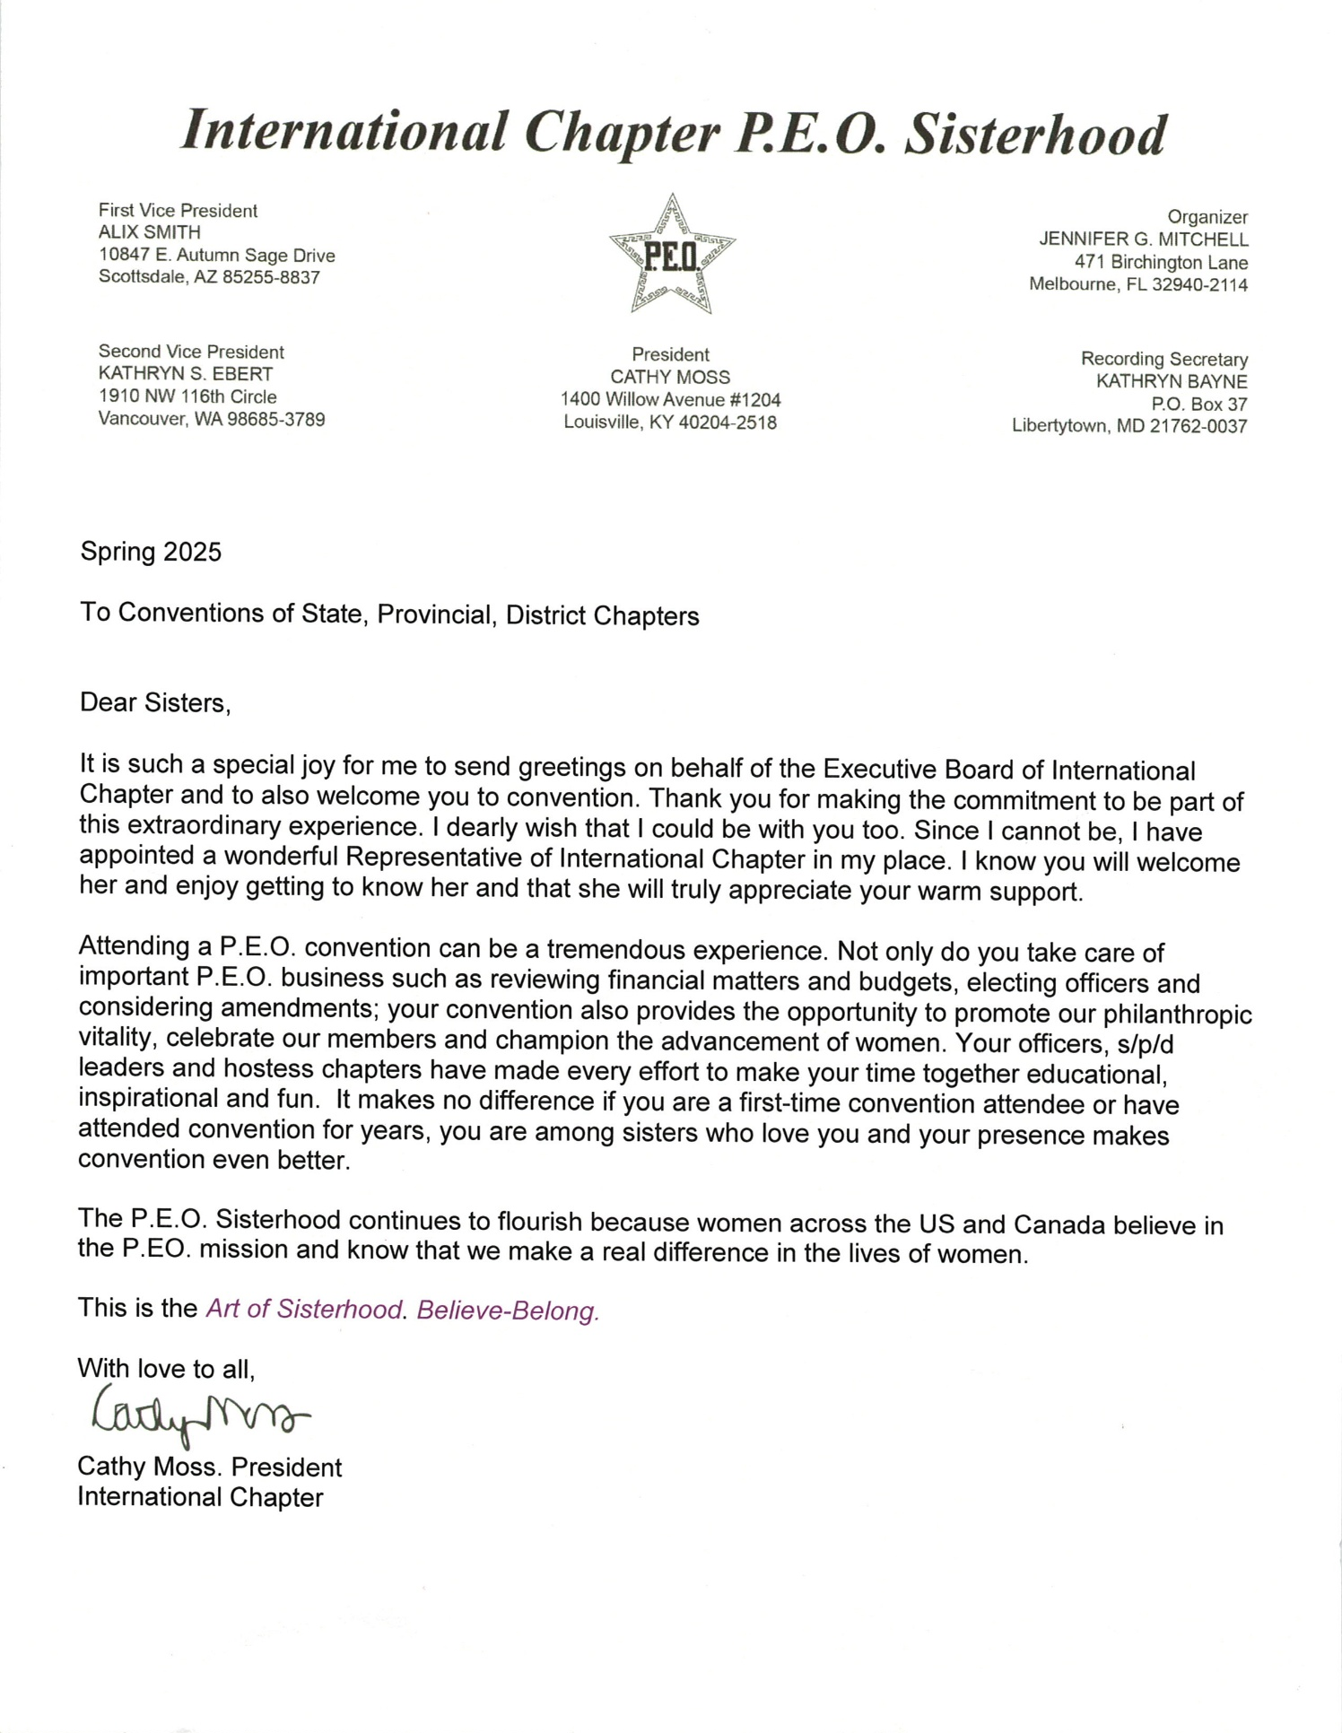

ALABAMA STATE CHAPTER ANNUAL REPORTS TO INTERNATIONAL
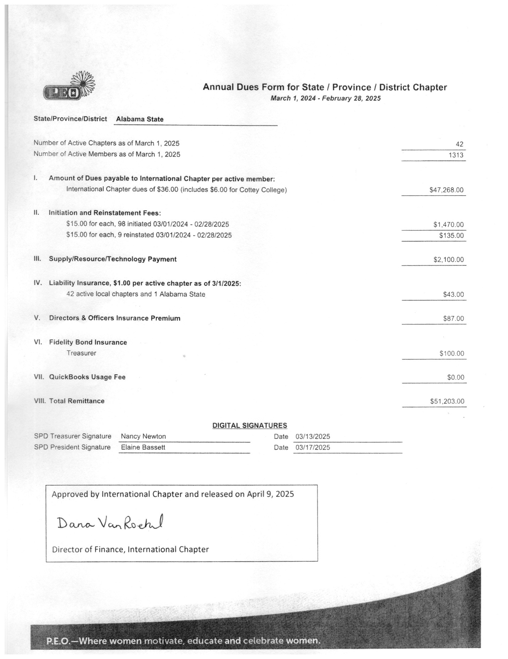

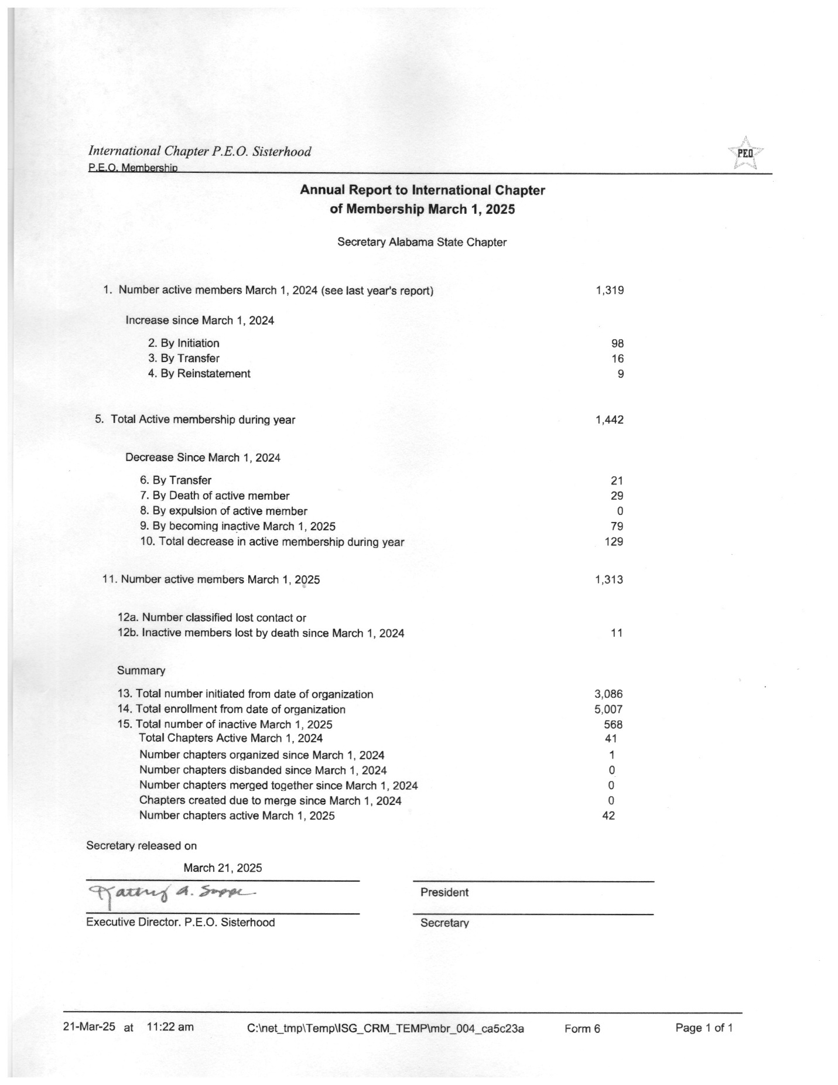

FINANCIAL DOCUMENTS

SUMMARY OF RECEIPTS AND EXPENDITURES BY FUNDS
FUND | BALANCE  4/01/2024 | RECEIPTS | DISBURSEMENTS | Transfers | BALANCE  3/31/2025
General Fund | $23,282.91 | $301,135.35 | $293,858.98 | -$6,000.0 | $24,559.28
Convention Fund | $18,737.04 | $13,399.16 | $20,750.77 | +$6.000.00 | $17,385.43
Alabama Cottey Scholarship Fund (ACSF) | $63,744.25 | $8108.01 | $2000.00 | $0.00 | $69,852.26
Reserve Fund | $9,772.15 | $351.90 | $0.00 | $0.00 | $10,124.05
Total Assets | $115,536.35 | $322,994.42 | $316,609.75 | $0.00 | $121,921.02

TOTAL CHAPTER GIVING TO P.E.O. PROJECTS 2024-2025
TOTAL GIVEN: $327,906.02
Cottey | ELF | IPS | PCE | PSA | STAR | Foundation | ACSF
$12,940.00 | $16,380.00 | $25,758.00 | $50,562.90 | $38,830.00 | $30,262.00 | $147,353.12 | $5820.00

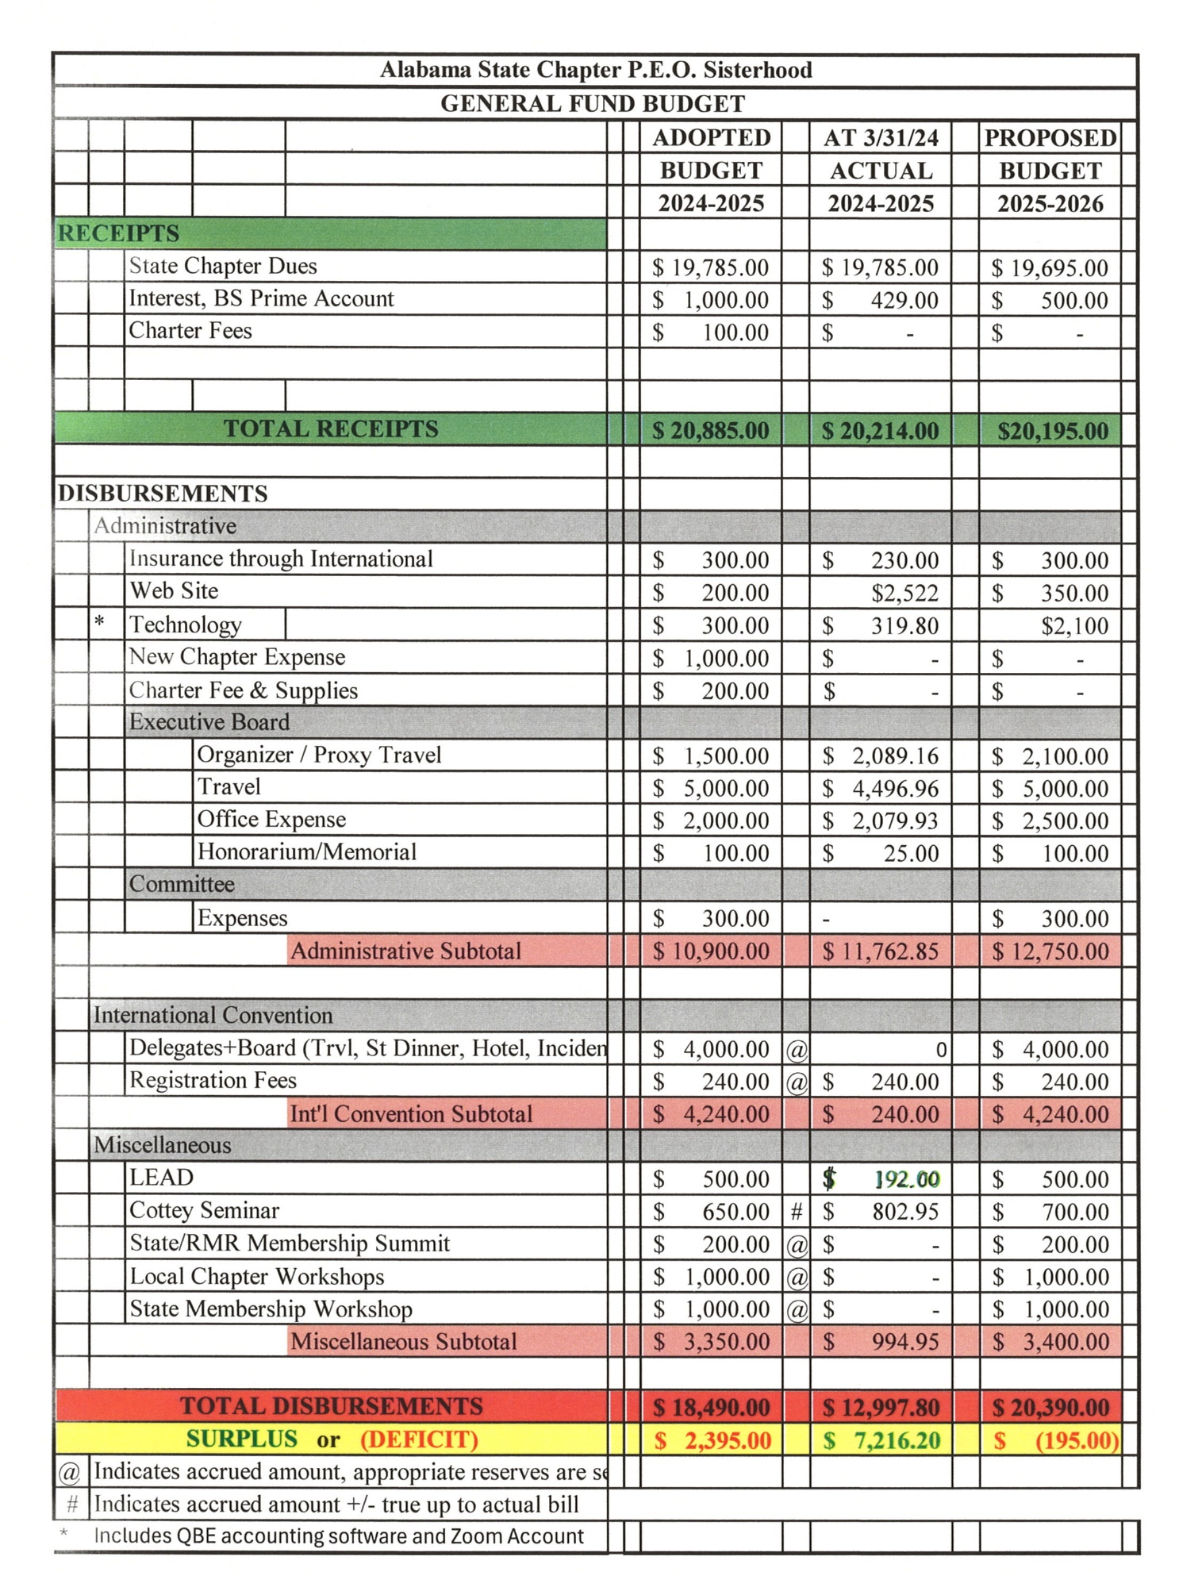
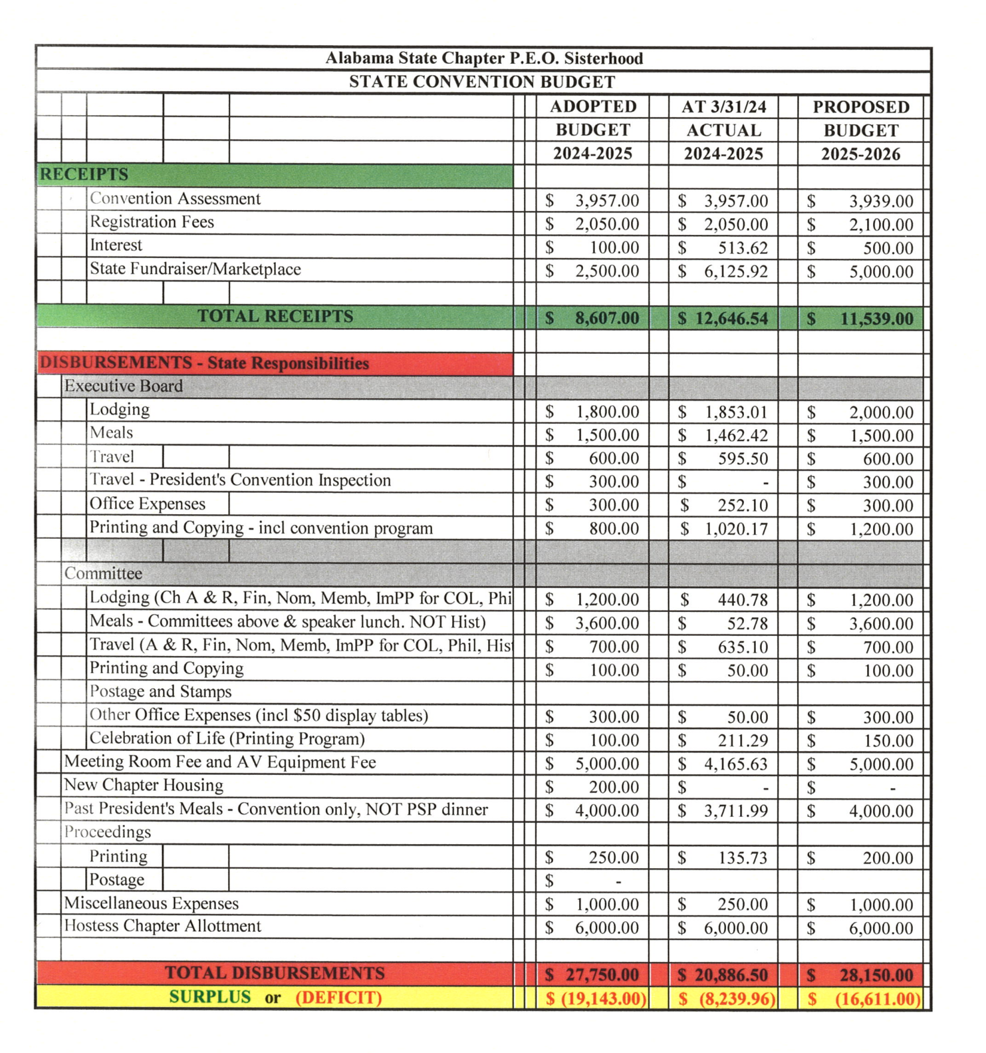

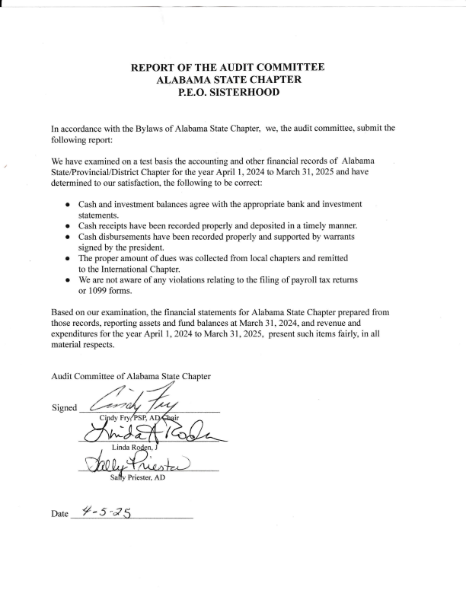
 | ALABAMA STATE CHAPTER
 | GIFT LOG for 2024 - 2025
 | TOTAL HONORARIUMS AND MEMORIALS RECEIVED: $150,961.036
 | P.E.O. Education Loan Fund
 | CHAPTER GIVING INDIVIDUAL GIVING
 | Given by | In Honor of | k | Given by | In Honor of
 | Chapter O | Claudia Graham | k | Katherine Halverson | Mary Dalrymple
 | Chapter H | Cindy Fry | k
 | Chapter Q | Alka B. Hargav | k
 | Chapter X | Beth Witten | k
 | Chapter X | Sgts B. Nesmith & W Sistrun | k
 | Chapter X | Jessica Rizzo | k
 | Given by | In Memory Of | k | Given by | In Memory of
 | Chapter M | Inactive Sisters | k | Betty Von Hermann | Anne Berte
 | Chapter X | Betty Simes | k | Betty Von Hermann Joe Thompson
 | Chapter X | Lois Graves | k | Patricia Fitzgerald | Thelma Dee Brittain
 | Chapter F | Wilhelmina Vigee | k
 | Chapter F | William Mackey | k
 |  |  | k | Total ELF Honorariums/Memorials: $1,001.00
 | Cottey College
 | Given by | In Honor of |  | Given by | In Honor of
 | Chapter M | Jennifer Macie
 | Chapter Y | Carol Lassiter
 | Chapter Q | Alka Hargav
 | Given by | In Memory of |  | Given by | In Memory of
 | Chapter C | RE Talbott
 | Chapter C | TR Willis

 | Chapter M | Joy Groenke | e Ho
 | Chapter C | Dick Pennington | e Ho
 |  | Total Cottey Colleg | e Ho | norariums/Memorials: $285.00
 | P.E.O. Program For Continuing Education
 | Given by | In Honor of |  | Given by | In Honor of
 | Chapter G | Susan Heiser |  | Mary Wiley | Cindy Fry
 | Chapter O | Gail Mosely |  | Mary Wiley | Nancy Newton
 | Chapter Q | Doug Ripley |  | Elaine Bassett | Dr. Shellye Vardaman
 | Chapter X | Beth Whitten
 | Chapter X | Sgts Nesmith &Sistrunk
 | Chapter X | Jessica RIZZO
 | Chapter AJ | Paige McCormick
 | Chapter AE | Vickie Simmons
 | Chapter C | Mary S. Palmer
 | Chapter C | Kathy Hicks
 | Chapter C | Libba Vanderbeek
 | Chapter C | Childrens & Womens Hos
 | Chapter X | Michelle Schultz
 | Chapter X | Denise Lewis
 | Chapter C | Rua Flores
 | Chapter B | Sue Wellman
 | Chapter AK | Cel Bailey
 | Chapter V | Elaine Bassett
 | Given by | In Memory of |  | Given by | In Memory of
 | Chapter J | Sue Nichols |  | Betty Von Hermann | Pamela Pullen
 | ChapterW | Catherine (Tag) Hogue |  | Martha Hastings | Pamela Pullen
 | Chapter AH | Arlene Christman |  | Elaine Bassett | Dr. Shellye Vardaman
 | Chapter J | Patti Monroe |  | Patricia Fitzgerald | Thelma Dee Brittain
 | Chapter W | James Johnson
 | Chapter AB | Jack Gifford
 | Chapter AB | Edmond Paul Hamel
 | Chapter V | JT Brown
 | Chapter I | Helen Gibson
 | Chapter I | Tom Poe
 | Chapter AH | Stephanie Philbrook
 | Chapter W | Dale Shaw
 | Chapter S | Peggy Hallmark
 | Chapter H | June Williams

 | Chapter M | Peggy Schlemmer
 | Chapter F | Mary Taylor
 | Chapter AJ | Judy Berry
 |  |  |  | Total PCE Honorariums/Memorials: $33,455.00
 | P.E.O. International Peace Scholarship
 | Given by | In Honor of |  | Given by | In Honor of
 |  |  |  | Katherine Halverson | Helen Mari Ley
 | Chapter R | Gayle Howell |  | Candy Griffin | J and M Dollar Discount
 | Chapter W | Paige McCormick |  | Elizabet Davis | Leonette Slay
 | Given by | In Memory of |  | Given by | In Memory of
 | Chapter X | BettySims |  | Patricia Fitzgerald | Thelma Dee Brittain
 | Chapter T | David W. Wright
 |  | Total P.E.O. Internationl Peace Scholarship Honorariums/Memorials: $12,926.00
 | P.E.O. Scholar Awards
 |  |  | Hon
 | Given by | In Honor of | Hon | Given by | In Honor of
 | Chapter T | Sharon Adams | Hon
 | Given by | In Memory of | Hon | Given by | In Memory of
 | Chapter M | Betty Carson | Hon | Cel Bailey | Sally Moutardier
 | Chapter J | Sue Nichols | Hon | Patricia Fitzgerald | Thelma Dee Brittain
 | hapter AC | Kathy Byrd | Hon
 |  | Total Scholar Awards | Hon | orariums/Memorials $25,280.00
 | P.E.O. STAR Scholarship
 | Given by | In Honor of |  | Given by | In Honor of
 | Chapter V | Betty & Jamie Smith |  | Miriam Morrow | Dee Dee Given

 | Chapter A | RAPA |  | Miriam Morrow | Cecelia Bailey
 | Chapter A | VCOM |  | Katherine Halverson | Helen Mari Ley
 | Chapter A | Auburn Bank
 | Chapter M | Marilyn Cardino
 | Given by | In Memory Of |  | Given by | In Memory Of
 | Chapter J | Sue Nichols |  | Susan Moore | Annalee Hodge
 | Chapter A | Ruth Priester Spencer |  | Melaine and John Smyth | Sherel Carpenter
 | Chapter A | Edward Lee Spencer Jr. |  | Carol Reed | Sherel Carpenter
 | Chapter G | Frank Rosa |  | Katherine Niebuhr | Sherel Carpenter
 | Chapter AG | Barbara Wilson |  | Camille Rivenbark | Sherel Carpenter
 | Chapter AG | Brandon Quinn |  | Patricia Fitzgerald | Thelma Dee Brittain
 | Chapter F | Amy Sims
 | Chapter O | Tommy Mosely
 | Chapter A | Sherel Perry
 |  |  | ums/
 |  | Total STAR Honorari | ums/ | Memorials $25,280.00
 | P.E.O. Foundation
 | Given by | In Honor of |  | Given by | In Honor of
 | Chapter B | Ann Dudleson |  | Betty Von Herrmann | Cindy Fry
 | Chapter T | Judy Holt |  | Betty Von Hermann | Elaine Bassett
 | Chapter AK | Gena Stoves |  | Mr. and Mrs. Gary Raby | Joel Philhours
 |  |  |  | Betty von Hermann | Mark Perry
 |  |  |  | Eddie McDonal | Joel Philhours
 |  |  |  | Janet McDuffie | Joel Philhours
 |  |  |  | Dede Moore | Joel Philhours
 |  |  |  | Betty Von Hermann | Neal Travis
 |  |  |  | Align Org Solutions | Julie Breeden
 |  |  |  | Tom and Joan Phillips | Julie Breeden
 |  |  |  | Women on the Journey Sunday Sch | Julie Breeden
 |  |  |  | Michele Suttle | Julie Breeden
 |  |  |  | Colette Scott | Julie Breeden
 |  |  |  | Martha Hastings | Neal Travis
 |  |  |  | Betty Von Hermann | Tommy Wells
 |  |  |  | Nancy Sizemore | Richardo Mussiett
 |  |  |  | Sabrina Heam | Joel Philhours
 |  |  |  | Linda Budge | Julie Breeden
 |  |  |  | Denise Barnes Burns
 |  |  |  | Paula Cushman | Lisa Sallo - Past State Pre

 |  |  |  | Sharon Averyt | Julie Breeden
 |  |  |  | Francis P. Hester
 |  |  |  | Melinda Hurd
 |  |  |  | Judy Jacobs
 |  |  |  | Nancy Sizemore | Bill James
 |  |  |  | Kathryn Ginanni | Julie Breeden
 |  |  |  | Frank and Marie Mineo | Julie Breeden
 |  |  |  | Sara Beauchamp
 |  |  |  | Nancy Sizemore | Larry Astin
 |  |  |  | Mary Berheim
 |  |  |  | Jo Ann Brazelton | Linda Butler
 |  |  |  | Carole McIntyre | Dee Dee Given
 |  |  |  | Karla Gniadaek | Patricia Franklin
 |  |  |  | Carol Westbrook | Nancy Newton
 |  |  |  | Cel Bailey | Diane Shepherd
 | Given by | In Memory of |  | Given by | In Memory of
 | Chapter AK | Mary Adler |  | Georgia Raby | Charlie Fridlin
 | Chapter T | Rachel Fowler |  | Nancy Sizemore | Frank Pamplim
 | Chapter G | Ann Andrews |  | Nancy Sizemore | Catherine Curry
 | Chapter AK | Charles Fridlin |  | Richard King
 | Chapter B | Sue Wellman |  | Pete Partin | Joel Philhours
 | Chapter B | Dick Trueb |  | JoAnn Brazelton
 | Chapter D | Carol Collier |  | David Salo | Elizabeth "Lisa" Salo
 | Chapter B | Julie Breeden |  | Bonnie Embry
 | Chapter B | Sue Wellman |  | Wendy James | Loura Jean Jack
 | Chapter AK | Joel Philhours |  | Tee Daugherty | Joel Philhours
 | Chapter AA | Neal Travis |  | Susann Vandevelde | Joel Philhours
 | Chapter AA | Mark Perry |  | Alisa Shivers
 | Chapter U | K Livingston & H &B Miller |  | Eugenia Loggins
 | Chapter AA | Tommy Wells |  | Becky Young
 | Chapter D | Pat Mize |  | Norma Aldridge
 | Chapter U | Katy Livingston |  | Martha Cater
 | Chapter D | Peggy Darby |  | Carol Prosser | Joel Philhours
 | Chapter B | Jim Fink |  | Nancy Fridlin | Joel Philhours
 | Chapter J | Sue Nichols |  | Mr and Mrs Lyle Walker | Joel Philhours
 | Chapter AM | Ann Smith |  | Joe and Bonnie Embry | Joel Philhours
 |  |  |  | Judith Daniel | Joel Philhours
 |  |  |  | Martha Chitwood | Joel Philhours
 |  |  |  | Betty von Hermann | Joe Thompson
 |  |  |  | Kathy & Larry Beaumont | Julie Breeden
 |  |  |  | Neil Goff
 |  |  |  | Sheran Hodges | Julie Breeden
 |  |  |  | Susan and Bob St. Jean | Julie Breeden
 |  |  |  | Alice Jane B. Hagler

 |  |  | ound | Frances and John Peterson
 |  |  | ound | Elizabeth Oneal | Joel Philhours
 |  |  | ound | Mr. and Mrs. Don Waters | Joel Philhours
 |  |  | ound | Charles Aktins | Julie Breeden
 |  |  | ound | Carol and Dave Ramsey and Family | Julie Breeden
 |  |  | ound | Molly Trueb | Julie Breeden
 |  |  | ound | Susan Blair | Joel Philhours
 |  |  | ound | Nancy Benner | Julie Breeden
 |  |  | ound | Lynne Heaven
 |  |  | ound | Peggy Goodwin | Joel Philhours
 |  |  | ound | Amy McIntyre
 |  |  | ound | Cynthia A. Secrist | Julie Breeden
 |  |  | ound | Mr. and Mrs.Philip Robertson | Joel Philhours
 |  |  | ound | Mr. and Mrs. Pedro Verdu | Joel Philhours
 |  |  | ound | Greg Compton | Elizabeth "Lisa" Salo
 |  |  | ound | Jeri Wnitney Crabtree | Julie Breeden
 |  |  | ound | Katherine Niebuhr | Sherel Perry
 |  |  | ound | Nancy Sizemore
 |  |  | ound | Gwenn Davis | Elizabeth Ann Smith
 |  |  | ound | Nancy Sizemore | Doris Avery Nichols
 |  |  | ound | Mary Compton | Lisa Sallo
 |  |  | ound | Anonymous | Lorraine Dolly Cockle
 |  |  | ound | Paula Cushman | Lisa Sallo PSP
 |  |  | ound | Nancy Sizemore | Joe Files
 |  |  | ound | Nancy Sizemore | Eddie Werneth
 |  |  | ound | Mavis Smith | Sally Moutardier
 |  |  | ound | Amy George | Dan and Judy Lesley
 |  |  | ound | Pete Partin | Alexandria Parrish
 |  | Total F | ound | ation Honorariums/Memorials | $52,367.36
 | Alabama Cottey Scholarship Fund
 | Given by | In Honor of |  | Given by | In Honor of
 | Chapter AC | Wendy James |  | Francis Quick | Cindy Fry
 | Chapter L | Wendy James |  | Susan Santoli (PSPs) | Joy Gloria Edwards Guill
 |  |  |  | Susan Santoli | Wendy James
 | Given by | In Memory of
 | Chapter AL | Gary Lehr |  | Given by | In Memory of
 | Chapter C | Sharon Adams
 | Chapter D | Bill James

 | Chapter AO | Sarah Moutardier | Tota
 | Chapter AO Gretchen Boiling |  | Tota
 | Chapter AO | Patrica Elder | Tota
 |  |  | Tota | l ACSF Honorariums/Memorials $367.00
 |  | Grand Total Honorariums/Memorials: $150,961.00

2025 STATE PHILANTHROPY COMMITTEE REPORTS

Alabama Cottey College Recruitment and Scholarship Committee (ACCRSC)
2024-2025

Over the past year, This Committee has:
- Met via Zoom on the 3rd Tuesday of each month beginning in August 2024, except for December. We met in January and February and had a final meeting in March.
- Continued the schedule of sending notes of encouragement and care packages to our Cottey Students.
- Provided recommendations to the board to increase the Alabama Cottey College Scholarship to increase the amount of the scholarship to $5000.00 per year as opposed to $4000.00. With $2500.00 sent each semester.
- Made the following recommendations to the Alabama State Board for suggestions about how Cottey may address the lack of financial transparency per the article in “The Record”.
- Request International P.E.O. to intervene and possibly hire an outside firm to conduct an audit.
- Provided Scholarship forms to Elena Adams.
- Completed necessary forms for the foundation scholarships to be awarded.
- Contacted Cottey with Scholarship award amounts for Elena Adams.
- Ordered Convention information from Cottey.
- Sent information out to the chapters quarterly.
- Made updates to the Alabama Cottey Website as necessary.
- With 27 of the 42 chapters reporting, Alabama has given $12,940 to Cottey College and sent $5,820.00 to the Alabama Scholarship fund. 11 chapters were Luminary Chapters.

The Committee members were grateful to be able to serve in our capacity in 2024-2025 and were pleased to increase the amount of Alabama’s Scholarship. We are pleased that there is interest from a new student in 2025-2026.

Respectfully submitted,
Sarah Gilbert, Q, Chair
Susan Tanner, S
Cynthia Lumpkin, AH

P.E.O. Educational Loan Fund (ELF) Committee

We are pleased to provide the following details based on submitted reports concerning ELF in Alabama this year:
- Total Contributions to the ELF Project by Alabama Chapters: $16,380
- Total # of Alabama Chapters contributing to ELF Project: 34 or 85%
- Total # of Alabama ELF Legacy Chapters: 22 or 55%
- Largest Donation by one chapter: $1000
- Number of Loans given out: 5
- Total in ELF Loans for this year $90K
- Total # of Chapters that sponsored a candidate: 7
Actions of this over the last year:
- Provided reports during the year to the Alabama State Board
- Answered questions for chapters in regard to ELF Loans
- Sent an email providing links to all things ELF to the Alabama ELF Chairs
Respectfully submitted,
Beth Beck, Z, Chair
Dawn Daly, E

P.E.O. International Peace Scholarship (IPS) Committee

Total Sponsoring (Legacy) Chapters: 16 (B, C, D, E, H, J, L, M, O, P, S, V, X, AB, AC, AJ, AK, AM)
Total Amount Chapter Contributions: $ 25,758
Total # PIP Recipients assigned to PIP Chapters 2024-25: 14 (B, D, E, H, L, M, O, S, V, X, AB, AC, AK, AM)
Local # Chapter Annual Reports Received: 29/41

Duties Accomplished by IPS Committee:
- Rec’d from IC: PIP Chapter Assignments for US/CDA; IPS PIP Match (Award Year 2024), Attended IC Webinar in September 2024 – Shared webinar link with AL Chapters, Received PIP 2024 Legacy Chapter List (Assignments will be made for 2025-26 August/September).
- Compiled list of AL Chapter emails and sent IC webinar link, Emailed AL Chapters reminding / requesting Annual Reports.
- Contacted PIP Chapters regarding speaker for AL State Convention 2025.
- Worked with State Officers to secure Convention speaker.
- Secured speaker (Video) for Convention (Alessandra Rodriguez Mercado) PIP from Chapter S. Sent her “Guidelines for Project Speakers at State Convention,” Photograph/Publicity Release for electronic signature, and request for printed copy of speech.
- Prepared Convention Display Board, Theme of display board “LUV IPS… Become a Legacy Chapter and PIP.

IPS-PIP Fundraising ideas from sister chapters:
- Sell Boston butts and smoked turkeys.
- Monthly auction items
- Harvest Market
- Games Galore & Market Place
- Brags and Blessings
- Many listed “general”, “multi”, etc. fundraisers

How State Chair can better assist LC’s:
- Encourage IC to make IC website more user friendly and IPS-PIP information easier to locate.
- How to get a PIP.
- More information on how to contact local colleges/universities to let them know about the IPS program P.E.O. offers. We would like to have students in our area.
Respectfully submitted,
Carol Williams, L, Chair
Judy Wesson, L

P.E.O. Program for Continuing Education (PCE) Committee
Amount given by Alabama Chapters: $50,562.90
Total amount of direct gifts: $11,000.00
Local Chapters making contributions: 39
Number of Grant Awards to Alabama recipients: 36
Total amount awarded to Alabama recipients: $121,500.00
Brighter Tomorrow Chapters: 24 (B,C,D, E, H, I, J, L,M, O, S, T, U, V, W, X, Y, AB, AC, AE
AF, AG, AK, AM)
Number of Alabama chapter annual reports: 41/42

Committee Actions:
- Members of the committee received training from Nancy Newton.
- The committee chair created an email list for communication with chapters.
- PCE applications from International were received and forwarded to the local chapters in the candidate’s geographical area.
- Sent quarterly reports to Nancy Newton, state PCE advisor.
- Several informational emails were sent referencing information on the P.E.O. International website.
- Collected annual reports from chapters.

Summary of Chapter Annual PCE Reports:
- Twelve chapters had grant recipients.
One each for Chapters C, F, J, S, V, W, AD, and AK
Two for Chapter AH.
Four for Chapter D.
Ten for Chapter AL.
Twelve for Chapter E.
- Many of those chapters had candidates that received $4000.
- Chapter J was reported that a $32,000.00 gift was sent by a sister’s family to PCE in her memory.
- Direct gifts to candidates totaled $11,000.
- Some chapter fundraising activities included monthly raffles, soup sales, Hanging of the Green, cinnamon roll sales, barbeque sales, individual donations, yard sales, quilt raffle, plant and wreath sales, silent auctions, Bunco, “No Bake Sale”, Casserole sales, golf tournament.

Respectfully submitted,
Valerie Cox, AL Chair
Janice Candler, Y

P.E.O. STAR Scholarship Committee
2024/2025

Total Chapters submitting STAR 2024/2025 Annual Reports: 33 of 42
Total Applicants recommended by Local Chapters 2024/2025: 32
Total Alabama 2024/2025 STAR recipients of 32 recommendations: 12
Total Chapter applicants by Local Chapters for 2025/2026: 35
Total Chapter contributions to the STAR Scholarship: $30,262
(based on Alabama P.E.O. State Ledger)

2025 Constellation Chapters: A, B, C, D, E, H, I, M, O, S, T, U, V, X, Y, AB, AC, AF, AG, AK, AM

During the past year, the STAR Committee Members Dee Dee Given, Mandy McKenzie and STAR Advisor Paige McCormick, have been dedicated to encouraging and supporting the Alabama STAR Chairs.

Total Chapter dollar contributions an 86.5% increase for 2024/2025 over 2023/2024
Total Chapter applicants recommended: 9% increase for 2024/2025 over 2023/2024

Committee Actions:

- Manned AL STAR display at 2024 State Convention to answer questions and meet P.E.O. sisters supporting the STAR scholarship.
- STAR display at 2024 Convention included new STAR qualities poster/flyer.
- Reviewed updated STAR FAQ’s and Role and Responsibilities of S/P/D STAR Committee Chair for upcoming year.
- Shared STAR display board with a Birmingham chapter for their use in upcoming meetings
- Attended Zoom call by STAR Scholarship Board of Trustees
- Communicated goals of AL STAR Committee with Co-Chair and AL STAR Advisor
- Communications sent to known Chapter STAR chairs and Chapter Presidents regarding STAR application process, timelines, and updated FAQ document. Provided key contact information of Chair and Co-Chair for support and guidance.
- Sent communications to STAR chairs/Presidents highlighting Cottey College collaborative initiative with STAR scholarship and offered encouragement in identifying potential candidates.
- Provided STAR highlights for Al State President monthly newsletter.
- Communicated keys to a successful STAR applicant as provided from the STAR Board of Trustees Zoom call and additional sources to Chapter Chairs.
- Answered incoming questions from Chapter Chairs on how to submit application and log in requirements.
- Encouraged participation while sharing potential candidates from other chapters.
- Communicated friendly reminder of cut-off day and time to chapter STAR chairs.
- Answered questions regarding information on form submission confirmation process.
- Sent email to STAR chairs suggesting continued monitoring of their candidate’s receipt of link for application, 30-day timeline to submit application and required paperwork.
- Thanked STAR chairs for their support of the STAR philanthropy as we support women’s educational goals.
- Questions received after cutoff date: When will we know if the candidates have received a STAR award? When can I get a list of the recipients?
- Communicated request for completion and due date of STAR philanthropy annual Chapter report.
- Reviewed STAR chair annual reports for information and feedback.
- Worked to confirm a STAR recipient convention speaker.
- Compiled Alabama STAR State chair folder for 2024-2025 containing helpful process and communication information to pass to next Alabama STAR chair for 2025/2026.
- Prepared STAR display for April 2025 State P.E.O. convention in Tuscaloosa
2024/2025 Annual STAR Report Summary:
Chapter fundraising activities: soup and cookie sales, garage sales, plant and wreath sales, pecan sales, auctions, brown bag auction, raffles, Boston Butt/Turkey sale, Pampered Chef, jam sale, Games Galor, Krispy Kreme sale, Cottey Bingo Set sale. Numerous Chapters rely on sister donations and contributions.

Suggestions for the STAR Committee:
*Begin communications earlier in the year
*Have someone from State STAR Committee contact local guidance counselors about STAR Scholarship
* Provide STAR chairs with ideas to share at Chapter meetings
*Utilize social media to communicate to high schools for potential candidates
*Divide State into Regions and provide contact information for high school guidance counselors

Additional Annual report information:
*Feedback that new STAR flyer was an outstanding resource used for communications and interviewing
*Request for earlier communication of STAR recipient winners for those in the south to enable presentation at schools
*Annual Reports still turned in from Chapters who did not have a STAR recommendation
*Streamline application process for those recommended
*Several chapters provided direct donations to STAR candidates from Chapter Foundations
*International Website and P.E.O. Record highly used for STAR information
*Have State Board lobby for an increase to the current $2500 Scholarship amount

Respectfully submitted,
Dee Dee Given, D, Chair
Mandy McKenzie, AO, Co-Chair

P.E.O. Scholar Awards (PSA) Committee

Number of nominations internationally 759
Number of P.S.A. recipients 109
Amount of each award $25,000
Total value of awards $2,725,000
Local Chapters submitting nominees 9 (2024-2025)
Chapters: A (2), B, D, P, AK, C, E, J, R, AC
Chapters with successful nominees AL
Local Laureate Chapters 18
Chapters: B, C, D, E, G, P, V, AB, AK, H, L, M, S, O, AG, AM, AC, X
Local Chapters making contributions 30
Total Chapter contributions $38,830
Chapter Chairman Annual Reports received 30/42

Committee Actions:
- Members of the Committee received support and guidance from Chery Wiliams, Alabama State PSA Committee Advisor.
- The Committee Chair created an email list for communication with chapters. Several emails were incorrect on the roster.
- The Committee Chair attended Zoom PSA Seminar with the PSA Board of Trustees; both PowerPoint slides and transcript were shared with Chapter Chairs.
- The Committee Chairman referred potential candidates received from P.E.O. International Chapter, with name and contact information to Local Chapters.
- The committee members divided responsibility for the convention report, secured speaker (Video) for convention (Julia Di), and preparation of the convention display, and handouts.
- Members of the Committee answered questions from local chapters about critical application timelines and locating potential candidates.

Chapter Chair Comments:
- Chapter Chairs shared that both the State and International websites are not “user friendly”, making information gathering difficult.
- Chapters chairs shared continued reach out to past PSA recipients, that were used as a source to facilitate new PSA applicants and as a referral source for recruiting future candidates.
- Chapters shared new strategies in their search for qualified PSA candidates by “planting some seeds” with PSA qualifications; to guide Deans of the University of South Alabama Speech Pathology and Audiology departments and with mass student emails sent to potential Doctoral candidates enrolled in Troy University College of Nursing.
- The article from Winter 2025 Record, “The Life of a Doctoral Student” helped guide and alleviate confusion as to what makes a student qualified for nomination. More articles like this would be appreciated.

Summary Of Chapter PSA Reports:
- Contribution amounts ranged from $50 to $25,000. The most common amount was $500.
- Information for the reports came primarily from the P.E.O. Record and the P.E.O. International website, but also from previous PSA recipients, Chapter PSA files, material received at conventions, Alabama Star, and the State Chairman.

As members of the Scholar Awards Committee, we appreciate all the questions, suggestions, and excitement about the P.E.O. Scholar Awards as demonstrated by the Chapter chairs. We are thankful for our fellow P.E.O. sisters and applaud Chapter AL that supported their highly qualified candidate through the application process to become a P.E.O. Scholar Awards recipient.

Respectfully submitted,
Terry L Corley, L, Chair
Jane Searcy, R

OTHER REPORTS

Membership Committee Report 2024-2025

- The Alabama State Membership Committee, including Paige McCormick, state organizer, began monthly meetings (via Zoom) following the Alabama State Convention in May 2025. We did not meet in December. Becky Clines, our Regional Membership Representative, joined us in our meetings. Becky has been a real asset to our meetings, especially helping with International Wed-site membership data. She is a wonderful membership cheerleader, and we valued her input to increase the vitality of each chapter.
- We welcomed our newest committee member, Merrily Newton. The state regions were assigned as follows. Karen – all the chapters in North Alabama, Merrily -Birmingham and Anniston chapters, Lisa – Tuscaloosa, Montgomery, and Auburn chapters, and Luann – Mobile, Daphne, Foley, Dothan, Ozark, Troy, and Prattville.
- We continued communicating with our chapters using the “Monthly Minute for Membership.” Each committee member was responsible for preparing this newsletter for three months of the year and sending it to the committee to be forwarded to local chapters. Chapters were encouraged to share this monthly with their sisters. This newsletter was our primary tool of communication.
- WE continued to stress the importance of the unaffiliate data on the International site and encouraged members to contact names on the list then report the results back to our committee.
- Results from the Annual Membership Chair Report were favorable to continue the Minute for Membership. However, it was noted that some chapters do an occasional monthly report while some do a report each month.
- We planned the workshop for the Alabama State Convention. The theme for the workshop and display is, “Our Hearts Belong to P.E.O.”
- Our active membership on March 1, 2024, was 1, 442. We had thirty-two chapters that initiated ninety-eight sisters, sixteen sisters transferred from other states to our chapters, and 9 sisters were reinstated. We had twenty-one sisters who transferred to other states and twenty-nine who entered Chapter Eternal. Unfortunately, seventy-nine sisters chose to go inactive. As of February 2025, our membership is 1,319.
- Alabama is one of two states with no disbanded chapters.
Respectfully submitted,
Luann Rice, Chapter C, State Membership Chair
Karen Sargent, Chapter AL
Lisa Vardaman, Chapter AF
Merrily Newton, Chapter AM

Nominating Committee 2024 – 2025 Report

- The Nominating Committee has completed its duties in accordance with the procedures outlined in Article III, Nomination and Election of Officers of the Alabama State Chapter Bylaws, P.E.O. Sisterhood and with the state policies and procedures for this committee.
- A letter was emailed to all local chapter presidents in the fall of 2024 with the instructions and guidelines for submitting to the Nominating Committee. Attachments included a list of the qualifications and commitments involved in serving on the board and forms to be completed by the chapter and the applicant.
- The Nominating Committee reviewed each prospective candidate’s chapter recommendation and met with the candidates on Zoom.
- The nominee chosen for the office of Secretary, Alabama State Chapter is Sally Priester, Chapter AL. Sally’s background, P.E.O. experience, and credentials are impressive, and she will be an excellent addition to the executive board. A biographical information sheet with a photograph of Sally is provided to members of the convention.
- All succeeding members of the Executive Board of the Alabama State Chapter were contacted requesting their permission to submit their names for the subsequent office in succession. Each gave her written consent to have her name placed on the slate of officers for nomination.
- It has been my honor and privilege to serve on the Nominating Committee and the Committee wishes to express their sincere appreciation to all those who participated in the nomination process this year.

The Nominating Committee presents the following slate of officers for the year 2025-2026:

President………………………………................Cel Bailey, Chapter D
Vice President………………………………………Paige McCormick, Chapter AC
Organizer………………………..……………………Nancy Bishop Newton, Chapter AJ
Treasurer……………………...……………………..Chery Williams, Chapter AG
Secretary………………..…………………………..Sally Priester, Chapter AL

Wendy James, Chapter AP, PSP, Chairman
Shelly Salmon, Chapter AE
Judy Weaver, Chapter C

Finance Committee

In accordance with the duties defined in the P.E.O. Constitution and the Bylaws and Standing Rules of Alabama State Chapter, the Finance Committee submits the following report:
The budgets (General Fund) and Convention Fund) for the fiscal year April 1, 2025 – March 31, 2026, have been prepared collaboratively by the members of the Executive Board of the Alabama State Chapter and members of the Alabama State Finance Committee. The budgets were created based on discussions throughout the previous fiscal year regarding process changes, study and evaluation of receipts and disbursements for the past fiscal year, and expected revenue and expenses for the coming year.
The Committee recommends a $6,000 transfer from General Fund to Convention Fund.
The Committee appreciates the activities undertaken by the Alabama State Board: developing a new state website and implementing accounting software which will minimize cost and streamline processes and improve reporting.
Respectfully submitted,
Susan Richardson, C, Chair
Julia Naefe, AL
Carol Sue Lewis, G
Betty Smith, V, PSP

Report of Historian

What a beautiful sight it is to see so many shining faces gathered here—sisters—united by a shared purpose and a sisterhood that has stood the test of time.
Today, we pause to reflect, to celebrate, and most of all, to honor the incredible ways in which our chapters and sisters have shown their heart this year in P.E.O.
Let’s start with a momentous milestone: Chapter A is celebrating 95 years of sisterhood. That’s nearly a century of lifting up women, building friendships, and quietly changing lives. Imagine the stories those walls could tell, the laughter they’ve echoed, and the hands they’ve held through generations. Chapter A, your legacy is profound.
And then there's Chapter G, which just marked 70 years! A true testament to endurance, grace, and the power of commitment. Your continued service, love, and leadership inspire us all.
Now, if you're looking for inspiration wrapped up in energy and wisdom, look no further than Chapter I where one of our beloved 91-year-old sister continues to lead the monthly yard sale like a pro. Rain or shine, she’s out there turning treasures into tuition, helping women achieve their educational dreams, one yard sale at a time. This sister is truly showing the true meaning of being a PEO.
Chapter M also has something big to celebrate—60 wonderful years. That’s six decades of women coming together to support each other, dream bigger, and do better. And your light keeps shining bright.
Then we have Chapter S, where two of our very own golden girls, both celebrating their 60th year in PEO, also helped the chapter mark 45 years since its founding. Chapter S is proof that age is just a number and creativity has no limits.
From book swaps to book blind dates, from heartfelt traditions to those quirky "off-the-wall" events that make us smile and bond even closer—this is just a small sample of how our sisters have shown their heart, their humor, and their dedication this year.
Each chapter, each sister, each story—woven together into this incredible tapestry we call P.E.O. Every milestone is more than just a number—it’s a reflection of time well spent, lives touched, and a mission deeply lived.
We are dreamers and doers. We are caregivers and go-getters. We are women who show up—for each other, and for the causes we believe in.
So as we celebrate these beautiful achievements today, let’s carry this spirit forward. Let’s continue to lead with love, to act with purpose, and to show the world what it means to have a P.E.O. heart. Thank you, and congratulations to all of our chapters and beloved sisters. Here’s to many more years of joy, service, and sisterhood.
Respectfully submitted,
Lisa Vardaman, AF

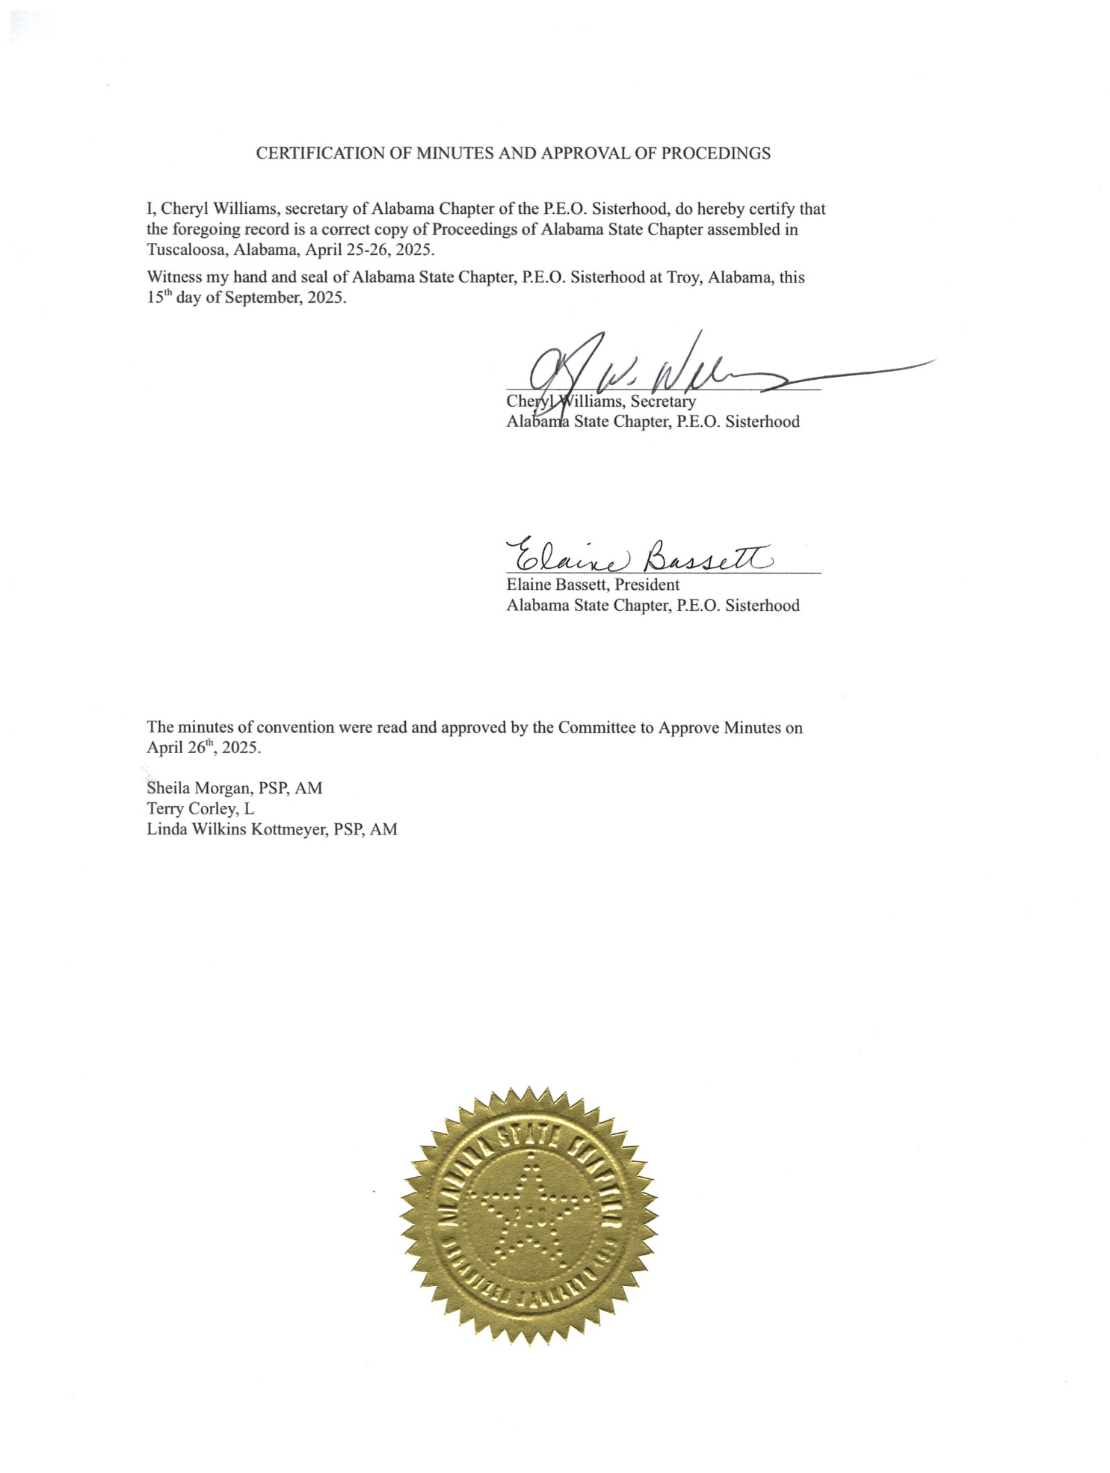

2024-2025 NOMINEE TO THE ALABAMA STATE BOARD
Sally Priester, Chapter AD

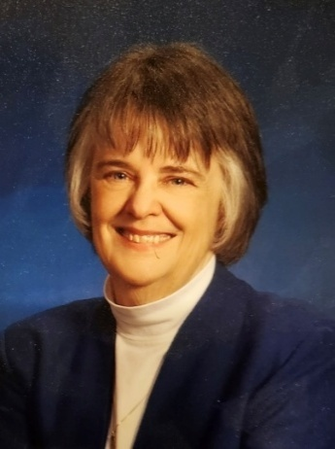
I was born and raised in central Illinois in a small factory and farming community. It was an idyllic upbringing, a time of being able to walk to school, play in the neighborhood all day and grow up as part of small town life. My father was determined that my older sister and I would have experiences outside of that small world, so he filled our young lives with travel to cities large and small. When I was 13, my father drove 200 miles with me so I could see a live musical theater performance in Chicago, and it changed my life. Three years later an audition for the School Chorus of America led me to a six-week tour with their national choir in Europe when I was 16 – a very big adventure for a girl from a small town. I was so fortunate to be able to attend Agnes Scott College for my undergraduate degree and the University of Georgia for post-graduate studies. A love of music and theater gave me an education full of vocal performance and theater arts. I then made my home in Atlanta, GA, starting an arts career that spanned over 40 years. I met my husband David in the backstage of a small Atlanta theatre, and during the many years with him I was fortunate to be able to continue singing professionally eventually establishing a small professional a cappella quintet, The Atlanta Notables. Over the years I directed over 40 musicals and revues, appeared in large and small shows, toured in theater productions, did voice-over and back-up recording work and sang throughout the South and Mid-west whenever possible. My son Tom was born in Atlanta, so I then continued working as a vocal coach and began a free-lance career as a fund-raiser and grant writer. In the meantime, my husband who was a television broadcast engineer working for Georgia Power and Southern Company, continued to design and build broadcast studios in Alabama, Georgia, and North Carolina. In the 1990’s he changed careers and became a full-time engineer for a broadcast design firm and took on his first large project with the IOC (International Olympic Committee). Because of his work with the Olympics we were part of several Olympic Games projects and eventually moved to Sydney, Australia, while he supervised the construction of the main broadcast center. My son and I had a wonderful year living in Epping, New South Wales, traveling all over Australia and even traveling to Asia when possible. Eventually we returned to the US and in 2003 we moved to upstate New York where my husband worked for Ithaca College Park School of Communications. I once again began to work for various churches as music director and singer and I eventually became the Interim Director of the Loaves and Fishes of Tompkins County NY, a large local community kitchen in Ithaca. During my time in New York, I was initiated into Chapter BJ/NY. It had always been my mother’s and my grandmother’s hope that I could join P.E.O. Previously because of all my traveling and short-term employment, I never resided anywhere long enough to fulfill residency requirement to join a local chapter. I will always be grateful to the sisters of Chapter BJ for inviting me to be a P.E.O. sister in their chapter. In 2012 I relocated to Huntsville, moving closer to my older sister in Birmingham and my adult son who lives in Atlanta. I promptly joined the Huntsville Community Chorus Association where I worked as Administrative Director until the summer of 2025. I continue to write grants for not-for-profits, sing whenever possible and support the arts in Alabama. Chapter BJ/NY was determined to find me a P.E.O. home in Alabama and I was able to transfer into Chapter AJ/AL the month after I arrived in Huntsville. Several years later I transferred into Chapter AD/AL to support this smaller chapter. I am truly blessed to have been part of Chapter AJ and to now be a current member of Chapter AD. I have created a lovely life in the South, surrounded by my P.E.O. sisters.

PROPOSED AMENDMENTS TO THE BYLAWS AND STANDING RULES OF
ALABAMA STATE CHAPTER

Underlined print = insert or add; Line through words = strike out.

PROPOSED AMENDMENTS TO THE BYLAWS OF ALABAMA STATE CHAPTER

- Submitted by the Executive Board and the Finance Committee of Alabama State Chapter
(page B-6) Amend ARTICLE VI, Section 2, paragraph 2, item 2, sentence 1, by striking out the word “prepare” and inserting the words “coordinate with the executive board in preparing”.
CURRENT WORDING | PROPOSED AMENDMENT | IF ADOPTED, IT WILL READ
To prepare a budget for the state chapter for the ensuing year, and to present this budget for consideration at convention of the state chapter. A copy of this budget shall be placed in the kits of members of convention. | To prepare coordinate with the executive board in preparing a budget for the state chapter for the ensuing year, and to present this budget for consideration at convention of the state chapter. A copy of this budget shall be placed in the kits of members of convention. | To coordinate with the executive board in preparing a budget for the state chapter for the ensuing year, and to present this budget for consideration at convention of the state chapter. A copy of this budget shall be placed in the kits of members of convention.
EXPLANATION: Would change the Finance Committee duty from preparing a budget for the state chapter to coordinating with the executive board in preparing a budget for the state chapter.

RATIONALE: Allows for the development of the proposed state budget to be a joint duty of the executive board and the finance committee.

- Submitted by the Executive Board of Alabama State Chapter
(page B-8) Amend ARTICLE VIII, Section 2, sentence 2, by inserting the words “or reorganized” following the words “a new”.
CURRENT WORDING | PROPOSED AMENDMENT | IF ADOPTED, IT WILL READ
Section 2—OFFICIAL VISITS TO LOCAL CHAPTERS. Official visits by the organizer shall be quinquennial. However, a new chapter shall be visited annually for the first three years. Any chapter may be visited … | Section 2—OFFICIAL VISITS TO LOCAL CHAPTERS. Official visits by the organizer shall be quinquennial. However, a new or reorganized chapter shall be visited annually  for the first three years. Any chapter may be visited … | Section 2—OFFICIAL VISITS TO LOCAL CHAPTERS. Official visits by the organizer shall be quinquennial. However, a new or reorganized chapter shall be visited annually  for the first three years. Any chapter may be visited …
EXPLANATION: Would add the requirement that a local chapter which has been reorganized shall receive an official visit annually for the first three years.

RATIONALE: Similar to a new chapter, a reorganized chapter benefits from an official visit for three consecutive years after reorganization.

EDITORIAL RESOLUTION

Resolved, That the 2025 – 2026 Executive Board of Alabama State Chapter be authorized to correct article and section designations, punctuation and cross-references and to make such other technical and conforming changes as may be necessary to reflect the intent of Alabama State Chapter.

INTERNATIONAL REPRESENTATIVE

Beverly Prewitt, Chair
P.E.O. Program for Continuing Education Committee

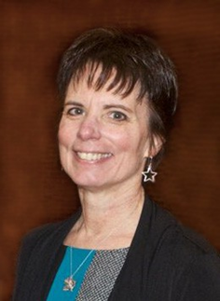
Beverly was introduced to P.E.O. and initiated into Chapter F, Hampton, Virginia by her aunt in 1994. She served as president of Virginia State Chapter from 2016-2017 and currently serves as chair of the Board of Trustees for the P.E.O. Program for Continuing Education. She is a member of Chapter DP, Cincinnati, Ohio. During her younger years Beverly trained extensively in classical ballet. After receiving a BFA degree in dance at North Carolina School of the Arts she toured and performed professionally in 46 states and 7 countries. She often shared leading roles with her future BIL and enjoyed the years of traveling, performing, and living out of a suitcase. After retiring from dance, Beverly switched from wearing costumes to creating them. In this capacity, she worked for Busch Gardens Costume Design Center in Williamsburg, Virginia, as shop supervisor. Prior to her retirement, she worked at Colonial Williamsburg’s Costume Design Center, overseeing all construction, patterning, and fitting of male historic garments worn by the 700+ costumed interpreters, including the well know Colonial Williamsburg Fife and Drum Corp. Beverly and her late husband Ricky have two sons, two grandsons, and a granddaughter. Upon retirement Beverly relocated to her native Ohio where she is fortunate to be near many relatives. In her spare time, she enjoys sewing, reading, swimming, camping, and hiking.
2025 PHILANTHROPY SPEAKERS

Cottey College

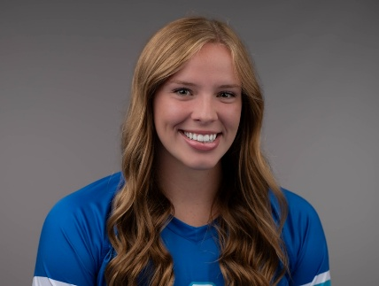
Elena Adams is from Prattville, Alabama. Her parents are Kim and Phil Adams, and she is third of six siblings. She attended public school until her last two years, spend at Edgewood Academy, a private school in Elmore County. She is a senior at Cottey College, working on her undergraduate degree in health and biomedical sciences with an expected graduation date of May 2026. Elena enjoys helping others and is passionate about her future in healthcare. Having always loved school, she wants to get a great education that she can apply to the rest of her life order to help others. Her goal is to obtain her master’s and become a Physician Assistant, after which she hopes to work in an emergency room and assist in surgeries. Elena plays volleyball at Cottey and also enjoys clubs like the pickleball club and STEM club. She loves lifeguarding at the YMCA and being part of the community both at home and in Nevada. Elena loves meeting new people and bringing smiles to people’s faces. One of her favorite things now is coming back home to warm weather to see her friends and family.

P.E.O. Educational Loan Fund

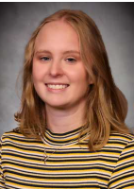
Sandra DeMaria graduated from UAB in 2022. She was born with a rare heart defect and was provided the unique opportunity to be exposed to many people who encouraged her to surpass all barriers placed upon her. Due to the impact of others in her life, she has been involved in many advocacy roles. Now, she has turned that ambition towards genetic counseling where she can work with those like her and, unlike her, can receive the care they need and surpass expectations. She was sponsored by Chapter AJ in Huntsville.

P.E.O. Program for Continuing Education

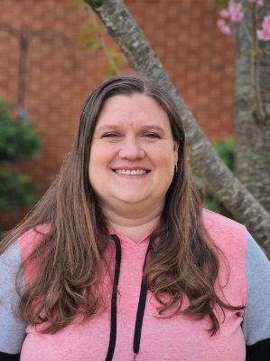
Emily Wyatt received a PCE grant from P.E.O. in 2024. She was recommended by Chapter AL, Madison and is the daughter of a Chapter AL sister. She is currently a senior at the University of Alabama studying Social Work. Emily will be starting an internship in August and will graduate with her bachelor’s degree in December. She plans to further her education by getting a master’s degree. Emily shares, “Addiction controlled my life for 6 years before I finally got sober in 2015. Due to my recovery, I became passionate about helping others struggling with substance abuse and mental health issues.”

P.E.O. International Peace Scholarship

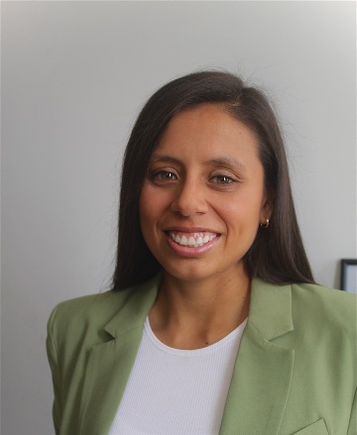
Alessandra Mercado is a master’s student in urban planning at Harvard and a Peruvian architect, with a strong passion for healthy cities, climate action, urban design, and public policies. With over six years of experience, she has contributed to the transformation of cities into more humane and sustainable environments through her work in both the public and private sectors. Her expertise includes developing master plan proposals, conducting urban diagnoses, urban design of public spaces, fostering citizen participation, and urban data analysis. In 2019, Alessandra co-founded 'Impostergable,' an urban planning office, and 'I'mappin', an urban technology start-up. She also leads 'La Fábrica de Chimbote,' an urban-cultural initiative in Chimbote, Peru. For 4 years, she has served as a teaching assistant in the architecture program at the University of Lima. Her academic accomplishments have been recognized with prestigious awards, including the Fulbright Scholarship, International Peace Scholarship, and a Peruvian scholarship.

P.E.O. STAR Project

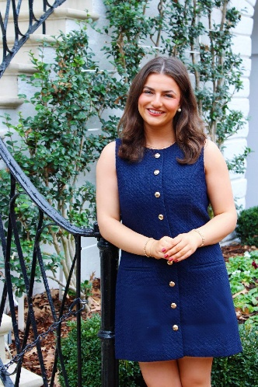
Madelyn Herwig, of the P.E.O. STAR Scholarship, has spent most of her childhood in Tuscaloosa, Alabama. Originally born in Duisburg, Germany, she has had the unique experience of living in both countries as a dual citizen. In high school, Madelyn served as President of Girls Learn International - Alabama Chapter, Youth Elder at First Presbyterian Church Tuscaloosa, and captain of both the Northridge High School Varsity Soccer Team and the Tuscaloosa United Club Team. This past August, she began her freshman year at the University of Alabama as a Blount Scholar, double majoring in English and Business on the Pre-Law track. After completing her studies, Madelyn aspires to work in the field of law, focusing on either Public Policy or Defense Litigation. On campus, she has become involved by being selected for the First Year Council of the UA Student Government Association, joining the Presbyterian campus ministry, UKirk, and most recently, being elected as a Senator in SGA for the Culverhouse College of Business in the upcoming term. Though she is passionate about building community and excelling in her academic work, Madelyn also enjoys baking, playing piano, and spending quality time with her friends and family. She is excited for the opportunities ahead and looks forward to continuing to grow both academically and personally, with the support of the P.E.O. and its inspiring members.

P.E.O Scholar Awards

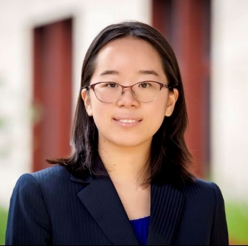
After reading a children's book about American astronaut Sally Ride at the local library, Julia Di became captivated by space exploration. During her first internship at NASA Marshall Space Flight Center as a robotics research associate, she realized her passion for advancing space robotic technology for both human and robotic exploration. Committed to this goal, she pursued robotics research, and is now pursuing a Ph.D. in mechanical engineering from Stanford University. She holds a B.S., magna cum laude, in electrical engineering from Columbia University and was nominated and is supported by Chapter AL in Huntsville.

2025 MILESTONE BIRTHDAY CHAPTERS

30 Years
Chapter AB--Daphne

40 Years
Chapter W—Dothan
Chapter X--Auburn

45 Years
Chapter T--Birmingham

60 Years
Chapter M--Huntsville

70 Years
Chapter F—Birmingham
Chapter G—Montgomery

75 Years
Chapter D—Birmingham


95 Years
Chapter A--Auburn

2025 SILVER SISTERS
25 Years

April Speaks, Chapter A
Nancy Hurst, Chapter B
Tammi K. Dacus, Chapter G
Jo Ann Cook, Chapter I
Jennifer Sherrill, Chapter N
Sondra Nystrom Leef, Chapter O
Gwen Westbrook, Chapter O
Mary Ruth Bean, Chapter P
Leah Graham Klotzbach, Chapter S
Sara Tennant Harris, Chapter T
Donna Hilson, Chapter W
Suzanne C. Currie, Chapter Z
Kathryn Tylor Teare, Chapter Z

2025 GOLDEN GIRLS

50 Years

Dianne D. Corwin, Chapter G
Carolyn Wheless, Chapter N
Starling Grisham, Chapter X
Mary Fuller, Chapter AB

55 Years

Judith Ann Stuckey, Chapter D
Judy Dillaber, Chapter H
Emily Kern Parsons, Chapter J
Joan Bell Roberts, Chapter L
Elizabeth Y. von Herrmann, Chapter AA
Nancy S. Kallus, Chapter AA
Paulette Boothe, Chapter AB

60 Years

Olyne Fischer, Chapter A
Sally Czepiel, Chapter C
Judith Rochman, Chapter G
Nadean E. Hankins, Chapter M
Martha Woodworth, Chapter M


Celebration of Life

Prelude Medley of Hymns
Call to Worship Psalm 91:1-2
He who dwells in the shelter of the Most High will rest in the shadow of the Almighty. I will say of the Lord, He is my refuge and my fortress, My God, in whom I trust.
Hymn “Precious Lord, Take my Hand”
Meditation Cindy Fry, PSP, Chapter AD
Chapter Eternal Roll Call
Past State President
June Williams, H
Sisters

Sherel Perry, A
Ruth Spencer, A
Julie Breeden, B
Mildred Jones, C
Carol Collier, D
Patricia Mize, D
Wilhelmina Vigee, F
Ann Andrews, G
Helen Gibson, I
Pam Rogers, J
Jo Colvin, M
Joy Groenke, M
Peggy Schlemmer, M
Joyce Boyd, Q
Ann Gebhart, Q
Peggy Hallmark, S
Marjorie Poe, S
Judith Holt, T
Linda Lewis, U
Dean Turney, U
Catherine Hogue, W
Dale Shaw, W
Virginia Hayes, X
Barbara Wilson, X
Pamela Pullen, AA
Mary Tom Stubbs, AA
Vergie Huggins, AB
Kathryn Byrd, AC
Judy Martin, AC
Shelly Salmon, AE
Audrey Vander Yacht, AE
Jerri Emerson, AF
Judy Beckvermit, AG
Sue Vosloh, AG
Judith Berry, AJ
Ann Smith, AM
Gretchen Boling, AO
Pat Elder, AO
Sally Moutardier, AO

Closing Song “Bless Be the Tie That Binds”

Benediction James 1:12
Consider it pure joy, my brothers and sisters, whenever you face trials of many kinds.

Postlude Medley of Hymns

Celebration of Life Committee Members Cindy Fry, PSP, AD; Jennie Oliver, J; Jenn Sherrill, N

President’s Opening Remarks

To all my dear Sisters of the Heart,

It is my pleasure to welcome you to the 66th annual convention of the Alabama Chapter of the P.E.O. Sisterhood.

This has been an exceptional year for the Alabama State Chapter of the P.E.O. Sisterhood! As I’ve read through your president’s letters and checked the contributions of all our chapters, I have been overjoyed at the generosity of our sisters—generous in money, time, and in LOVE! We have offered the gift of P.E.O. to over 80 women, and over $ 207,565 has been donated to the P.E.O. projects.

As your president this year, I am proud beyond words of all your hard work. During this year, I have fallen more in love with P.E.O. and my P.E.O. sisters. You give me such joy. I would like to introduce to you some very special sisters this afternoon before we get started. First, to my left (or right) is your vice president and everybody’s best friend, Cel Bailey, from Chapter D in Birmingham. Next is your tireless organizer, Paige McCormick, from Chapter AC right here in Tuscaloosa. Next is our diligent and patient Nancy Newton, your state treasurer, from Chapter AJ in Huntsville. Finally—but certainly not least—is the newbie of the group, who has found her home here on the board, Chery Williams of Chapter AG in Foley. These are such a wonderful board to work with! We have grown to love each other so much, and it has been my total pleasure to work with them over the years.

If you look around the room, you will see the best convention committee ever wearing blue aprons. These sisters from Chapters F, I, N, AI, and my own chapter AF have been working for almost two years getting this convention ready. We will see them again a little later.

Finally, I would like for the sisters from the following chapters to please stand: Chapters C, G, N, Q, X, AC, AD, AM, and AP. These sisters are from my buddy chapters. You may be seated. Oh how I love these sisters! And I will miss not being your board buddy next year. I’ve gotten attached to you! But you will be in really good hands.

Before we begin, let me make you aware of a couple of items. Today’s meeting is full of business, and there will be no official breaks. HOWEVER, please feel free to stand up and stretch whenever you need to, go to the back for water or coffee, or find your way to the ladies’ room in the hall outside the ballrooms. We will also have a few stretch breaks during the afternoon. We will try not to totally wear you out! We want you feeling good for tonight!

Now, it’s time for us to get down to business. Let’s get this show on the road!

Outgoing President’s Closing Remarks

As my time on the board comes to an end, I am pretty much at a loss for words—and that doesn’t happen often! All of you have made the past five years so full of joy. I’m going to try to say thank you, but if I omit anyone, I ask forgiveness up front.

To all of you I have been privileged to talk with and get to know (even through email or telephone), you’ve been a blessing to me. Not one time have I ever had a negative experience with an Alabama P.E.O. Now that’s saying something! You won’t find that happening in any other kind of organization, and that’s what makes P.E.O. so special.

To my buddy chapters: I love you all so much! You have supported me and encouraged me through these five years, and I have saved every one of the sweet cards and notes you have given me. Visiting with you during my organizer year was a highlight of my time on the board. You are precious to me.

To my own Chapter AF: You are my closest sisters, and I cherish all of you. Thank you for your support during these busy years.

To the best convention committee ever: ‘Nuff said. You. Are. The. Best.

To the sisters I’ve served with on the board: Linda, Denise, Wendy, Cindy, Cel, Paige, Nancy, and Chery—how is it that we have made it through these years, working together so well? It’s because we love each other. I have learned from you about P.E.O., about how to work with other people, how decisions are better if there’s collaboration among the members—I owe you all so much. We’ve been such a big part of each other’s lives, and I know we will continue to be.

To my family: I could not have survived without you all! My daughter/sisters make me proud to call myself their mama. And I’m truly happy that Jeremy Mead will be joining our family soon. You’re a good man, and I thank you for loving and caring for Katie and Ben. To the man who drives Miss Daisy everywhere—you are my one and only. And to little Ben—you really do light up my life.

As I name these wonderful people, I can’t help but feel blessed beyond words. God has gifted me with so much in my life, and the sweetest gifts are all right here in this room. I thank you for allowing me to serve our sisterhood on this executive board, and I can tell you with much assurance that you are in excellent hands. What you see on this dais are intelligent, loving, empathetic women who are dedicated to the ideals of P.E.O. Every one of them is a bright star, reflecting the light of P.E.O.
Once again, I thank you and I love you, my precious sisters of the heart!

Incoming President’s Remarks

Dearest Sisters,
I stand before you filled with gratitude, humility and honor as I accept the office of president of
the Alabama State Board. I know I have some pretty BIG SHOES to fill that can only be
accomplished with help from this AMAZING STATE BOARD, one of my greatest treasures, our
faithful PSPs and from each of our 42 chapters that YOU represent today.
So, where did MY STORY begin?

Approximately 10 years ago, I had no idea what P.E.O. was and certainly not what the letters
stood for or its purpose! I was totally engrossed in dreaming of my retirement bucket list while
training my staff to take over after 43 years in healthcare.
Shortly before my retirement, I was contacted by 2 dear church friends, Carole McIntyre and Jo
Ann Brazelton, who had obviously drunk the P.E.O. Kool Aid and sought to encourage me to
consider this organization as one of my involvements after retirement. I must truthfully tell you I
only heard a fraction of that conversation because nothing like that was on my carefully prepared
“Cel Bailey” bucket list.

Retirement Day came! And the invitations to attend the local chapter monthly programs started. I
remember sitting on the members’ decks, in bedrooms, and living rooms wondering what could
be under such high-level security where only members were allowed to be present.
Then, the day came for my initiation into Chapter D, Birmingham. A vivid memory filled with
tears, joy and love remains with me! Each and every time I participate in an initiation, those
beautiful words fill my heart with feelings of pride and love that bind us to one another!
Fast Forward to January 2021 when Chapter D nominated me for State Board. I quickly said
YES, then I found myself riding the fence, and finally saying NO. Enter 2 relentless PSPs. Have
you ever tried to say NO to Shirley Parramore or Carol Westbrook?? They even had my beloved
BIL saying YES!

Along with Denise Williams, Wendy James, Cindy Fry and Elaine Bassett, we were installed in 3
different rooms of outgoing president Linda Kottmeyer’s home during our 2021 virtual state
convention. May this be the one &amp; only time we experience this type of convention in our
lifetime!

My first year on the board was spent highlighting all the acronyms that Cindy Fry used multiple
times in one sentence. I would go home, find out what they meant &amp; attempt to memorize them for the next board meeting. I now walk in Cindy’s shoes as I was recently called out by two
Chapter S sisters. A BIG THANK TO YOU, Denise Williams for your leadership and guidance
during my first year on the Board.

I envisioned my second year as a piece of cake since I was the math scholar at Frisco City High
School. BUT, having others during my career prepare my spreadsheets and transact my
bookkeeping, I quickly realized that year two was going to be a humbling experience. Our most
able-bodied and encouraging State president Wendy James talked me down off the ledge several
times. And with the help of others-Janice Alcorn, Cindy Fry, Betty von Hermann, Linda
Kottmeyer, Holly Fondots; Elaine Bassett, I SURVIVED!!

Year 3 was a walk in the clouds! Pure Heaven! State president Cindy Fry predicted this would be
my MOST Favorite year and she was SO RIGHT! Spending quality time with chapters during
official visits, being part of the organization of two new chapters and our first every chapter
reorganization drove home where the heart of P.E.O. is! I was then ready to apply to be a lifetime
state organizer!

Year Four started out as “THE CALM BEFORE THE STORM”. The vice president has 2
responsibilities listed in The Spot Reminder. Another piece of cake, right. After our first board
meeting in May at Elaine Bassett’s, my first impressions proved wrong. At that time, my feelings
of 1% excitement and 99% “I’m not ready! I need at least 2 more years” began playing tricks on
my mind. Elaine’s calmness and encouragement has seen me through this year!
January rolled around and reality set in when I began to flip the 2025 calendar. 116 days till the
beginning of Our Story! Questions surfaced about what would be the most impactful for the
heart of our Alabama State P.E.O. sisterhood--our 42 local chapters? And how does one turn the logo artwork and theme words on paper into a meaningful goal for our sisters. By March, excitement and enthusiasm flowed through my veins!!

You have listened to my story of the past 4 years, let’s focus for a moment on OUR STORY for
this upcoming year.

“What will be our STORY? We’ve written our introduction with all your chapters’ responses to
my January request for your business meetings. When asked what your Dream, Sparkle and
Shine in P.E.O. on the International, state and local chapter level was: our first 14 chapters
responded with insightful ways to DREAM, our second 14 chapters responded with inspiring
ways to SPARKLE, and our last 14 chapters responded with the most meaningful ways to
SHINE. What a Golden opportunity as well as a challenge for us to collectively play a significant
role in 2025-2026 and beyond with reaching our fullest potential as we reach for the stars.
Chapter Delegates-please share my most sincere thanks for your chapter making time during
your very busy business meetings to collaborate on some meaningful ideas for our International,
State and local chapters to dream big, sparkle more and shine bright!
Our State Goals are included in your delegate packets along with a “Dream, Sparkle and Shine”
P.E.O. Bingo sheet to help your chapter achieve our goals. Please make sure each of your sisters
gets a copy of the Bingo Sheets-this will hopefully encourage participation of your entire
chapter.

So, let’s fast forward to April 25, 2026-will my outgoing remarks as I prepare to join our highly
admired PSPs in Daisy Patch be filled with a short story or with multiple chapters of ALL the
impressive ways our 1300 plus sisters made our DREAM, our SPARKLE and our SHINE in
P.E.O. an amazing reality in 2025-2026!
Dear Sisters: IT’s UP to US!

Convention Devotion

Given by Incoming Board Member, Sally Priester

Roman 12:10: Be devoted to one another in love. Honor one another above yourselves.

Love … How many times have each of us said, “Love you!” to family, friends, helpers, co-workers … and truly meant it? Because maybe your love, like mine, might come with different meanings.

Love … Have you ever used the phrase “I truly love them, but it is hard to like them all the time.” Because maybe this love has boundaries, limits, judgments all carried fully in our minds.

Love … Have you ever considered your love a sought-out gift, to be earned or carefully given?

The P.E.O. Love we show is so much more than any of these meanings. One thought we all share is the love of our sisterhood and the care we freely give to each sister. And the forward motion of this love carries to our projects, our meetings, our flowers on doorsteps for anniversaries, our social moments, our new initiates, phone calls, emails … and beyond. Love always needs to move throughout our chapters to our communities, our churches, our schools and neighbors and beyond … and then beyond all that even more. Where can we sisters better serve this love … maybe just beyond.

As we join together at this Alabama Convention let us embrace all of our qualities of Faith, Love, Purity, Justice and Truth … remembering that “the greatest of these is Love.” Let’s send a little more Love out into the world.

Let us pray:
Dear Lord, we thank thee for this time together as P.E.O. Sisters. Guide us to move beyond, sharing our love beyond our personal little worlds … using our caring and love with others, giving us the ability to make difference for others. Help us to embrace all that is good in our world. And may we always see your Love around us.
We ask this in Your Name
Amen

  - PAST PRESIDENTS OF ALABAMA STATE CHAPTER
Name | Address | Phone and Email
Margaret Sue Shoemaker, T  1979-1980 | 3547 Burlington Dr.  Fultondale, AL 35068-1984 | 205-849-1446
Sylvia Hellums, I  1980-1981 | 4946 Woodland Forrest Dr.  Tuscaloosa, AL 35405-5762 | 205-556-1990  sylted@comcast.net
Lauren Hilditch Watson, BC/FL*  *Chapter Disbanded  1986-1987 | 6223 Cassia St.  Bradenton, FL 34203-3620
Nancy McFeters, JL/WA  1993-1994 | 360 Grandview Ave  Camano Island, WA 98282-8636 | 360-926-8753  njmcfeters@gmail.com
Sheila Morgan, AM  1994-1995 | 3009 The Crossings at Riverchase  2171 Parkway Lake Dr.  Hoover, AL 35244 | 251-942-3216  golfer438@gmail.com
Marilyn Mancini, AC  1996-1997 | 15271 Four Winds Loop  Northport, AL 35475-3325 | 205-310-7489  marilynemancini@gmail.com
Patricia Franklin, G  1997-1998 | 2551 Eastchase Lane #60  Montgomery, AL 36117 | 334-224-6563  franklinpj@msn.com
Karla Gniadek, M  1998-1999 | 7797 Wildcreek Trail  Huntsville, AL 35802-3966 | 256-880-9037  kgniadek@aol.com
Mary Donald, Y  1999-2000 | 9412 Heathrow Dr.  Montgomery, AL 36117-5109 | 334-669-9116  mdonwtay@msn.com
Dani Halverson, E  2000-2001 | 660 Belmonte Dr.  Auburn, AL 36830-1282 | 334-821-8334 (h)  334-332-3824 (c)  halvekd@gmail.com
Debra Cunningham, Y  2001-2002 | 7712 Halcyon Forest Trail  Montgomery, AL 36117-3482 | 334-272-7060  dlbc629@gmail.com
Bette C. Bryan, W  2003-2004 | 107 Strawberry Lane, Apt. 2  Dothan, AL 36305-5860 | 334-281-1213  bettecbryan@gmail.com
Elizabeth von Herrmann, AA  2004-2005 | 1505 Parkside Court  Birmingham, AL 35209-4409 | 205-879-8137  vonannex@voncorp.com
Susan P. Santoli, CJ/NC  2005-2006 | 3405B Player Lane  Morehead City, NC 28557 | 251-709-1581  coachsps@bellsouth.net
Rebecca Drennen, G  2006-2007 | 8701 Carillion Place  Montgomery, AL 36117-8818 | 334-271-4001  rgd310@knology.net
Gayle Howell, AC  2008-2009 | 15318 Tierce Lake Rd.  Northport, AL 35475-3813 | 205-242-5436  gaylepeo@aol.com
Mary Wiley, AJ  2009-2010 | 1208 Clubhouse Ave., SW  Huntsville, AL 35802-5018 | 256-895-9110 (h)  256-651-6794 (c)  mgw128@aol.com
Holly Fondots, T  2010-2011 | 2018 Baneberry Dr  Birmingham, AL 35244-6402 | 205-985-9421  hollyf@aol.com
Patty Piro, AL  2011-2012 | 23216 Shinnecock Hills Dr.  Athens, AL 35613 | 256-694-2845  pattypiropeo@gmail.com
Carol Westbook, D  2012-2013 | 2237 Savoy St.  Hoover, AL 35226-1209 | 205-401-5515  cdwest43@gmail.com
Grace Anderson, U  2013-2014 | 1800 Rosedale St.  Muscle Shoals, AL 35661-1996 | 256-740-1606  graceandersonpeo@gmail.com
Betty Smith, V  2014-2015 | 156 Wood Place Court  Ozark, AL 36360-7582 | 334-790-4817  jamiesmith652@centurytel.net
Nancy Sites Sizemore, AG  2015-2016 | 6506 Callaway Acres Rd.  Gulf Shores, AL 36542 | 251-490-5015  nancyssizemore@gmail.com
Shirley Paramore, V  2016-2017 | 303 Lakes Dr.  Enterprise, AL 36330-7924 | 205-837-3644  sparamore21@gmail.com
Rebecca Reardon, AM  2017-2018 | 2340 Ridge Trail  Birmingham, AL 35242-3758 | 205-516-4202  burear@bellsouth.net
Janice Alcorn, AN  2019-2020 | 324 Reddock Rd.  Florence, AL 35633-1592 | 256-710-7739  alcornt@bellsouth.net
Linda Kottmeyer, AM  2020-2021 | 2137 Brook Highland Ridge  Birmingham, AL 35242-5871 | 205-283-1670  linda.kottmeyer.peo@gmail.com
Denise Williams, U  2021-2022 | 1401 Fairway Dr., SE  Decatur, AL 35601-6525 | 225-772-1453  denise.williams.peo@gmail.com
Wendy James, AP  2022-2023 | 1821 Wyeth Dr.  Guntersville, AL 35976 | 251-479-7048  alabamadaisygirls@gmail.com
Cindy Fry, AD  2023-2024 | 22898 Cog Hill Dr.  Athens, AL 35613 | 256-683-3890  cindyfrypeo@gmail.com
Elaine Bassett, AF  2024-2025 | 108 Deerfield Dr.  Troy, AL 36081 | 334-372-7329  elaine.bassett.peo@gmail.com

Past Presidents of Georgia State Chapter
Brenda Atkins, AA | 4020 Greystone Dr.  Birmingham, AL 35242 | 205-980-0503  bgatkins@weathertech.net
Mary Elizabeth Furnald, O | 9134 Martin Terrace  Gainesville, GA 30506 | 850-625-9752  mefurnald@gmail.com

Past Provincial President of Ontario-Quebec Chapter
Nancy Moran, E | 2010 Hummingbird Lane  Auburn, AL 36830 | 334-826-8400  ebbybartsgamgam@yahoo.com

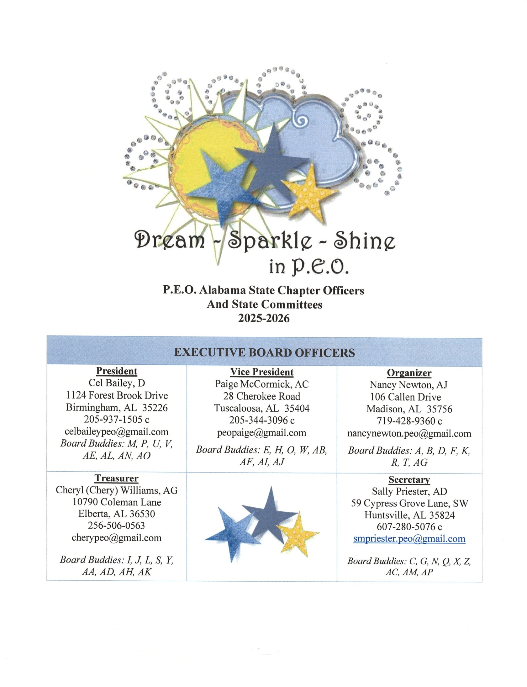

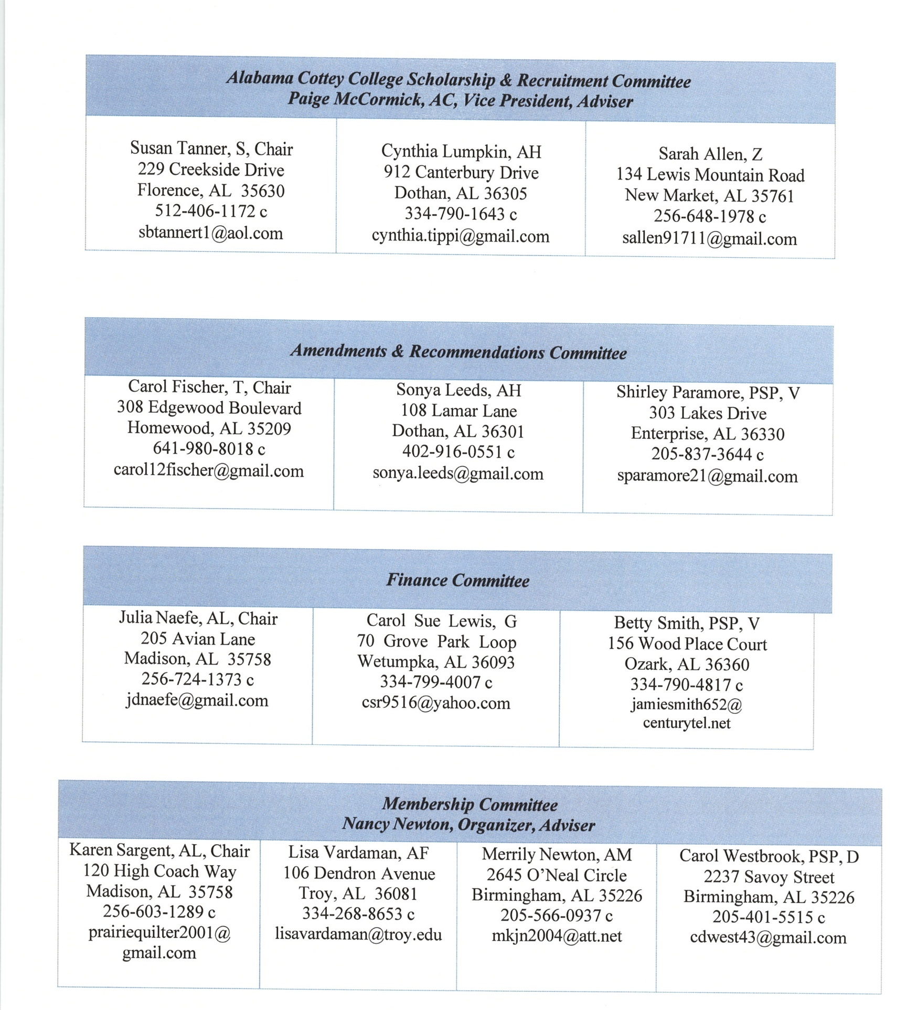

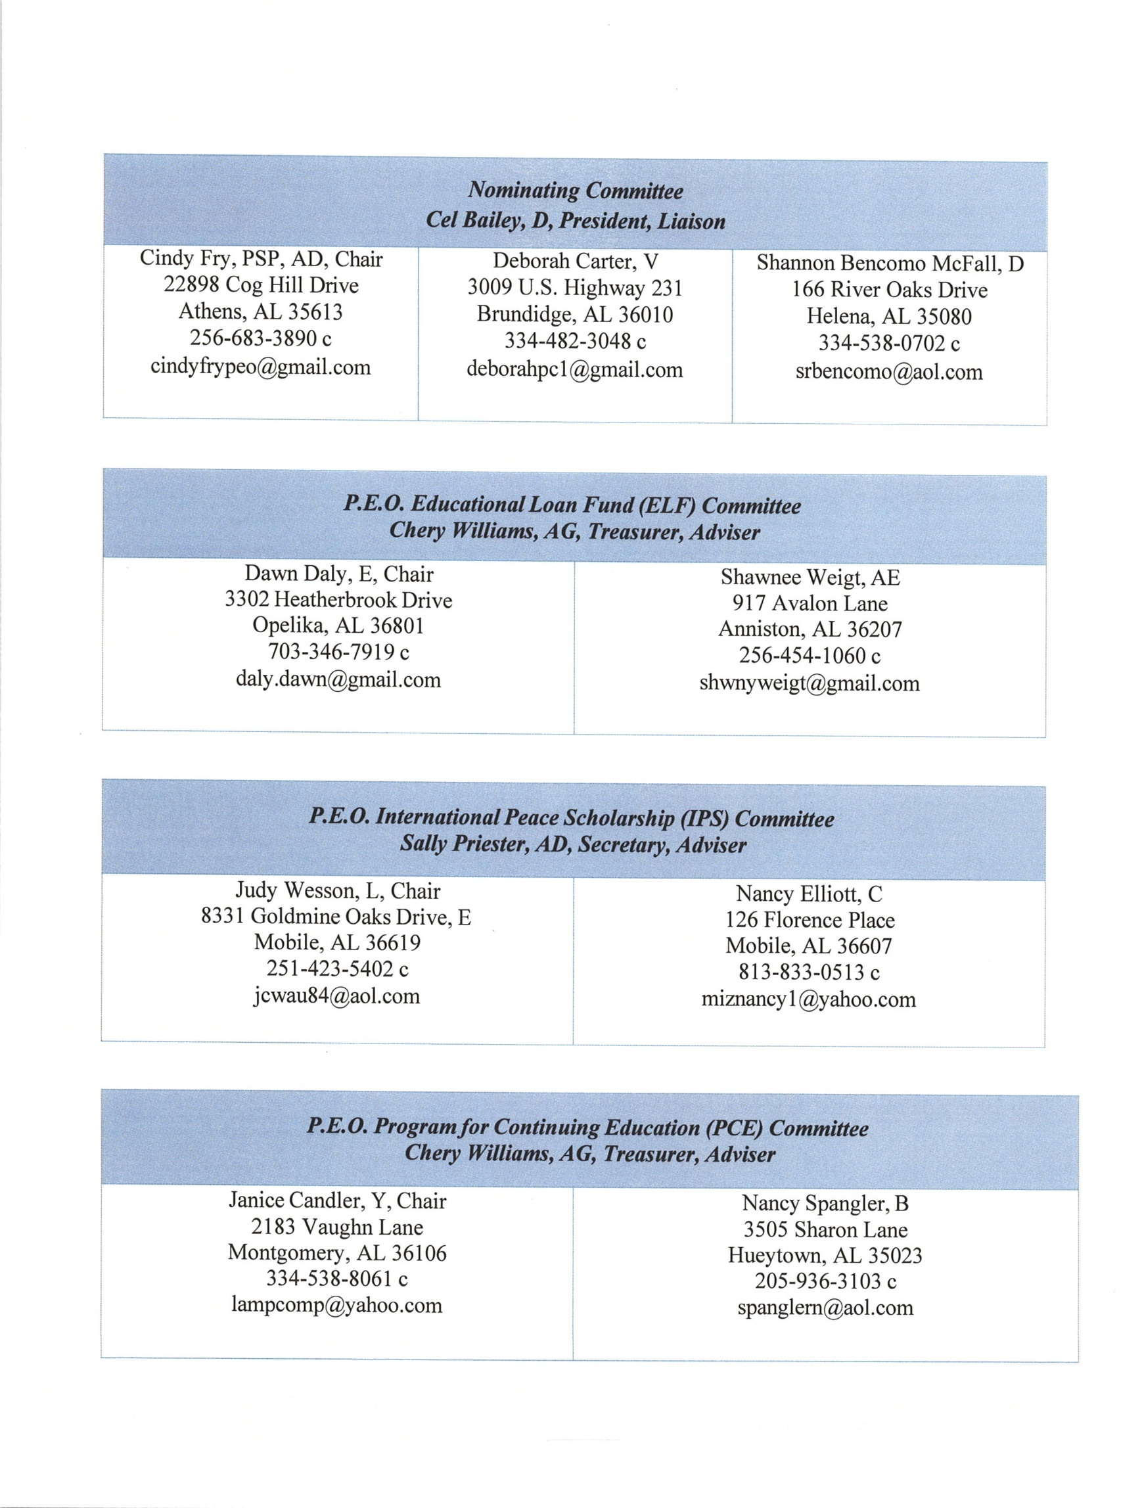

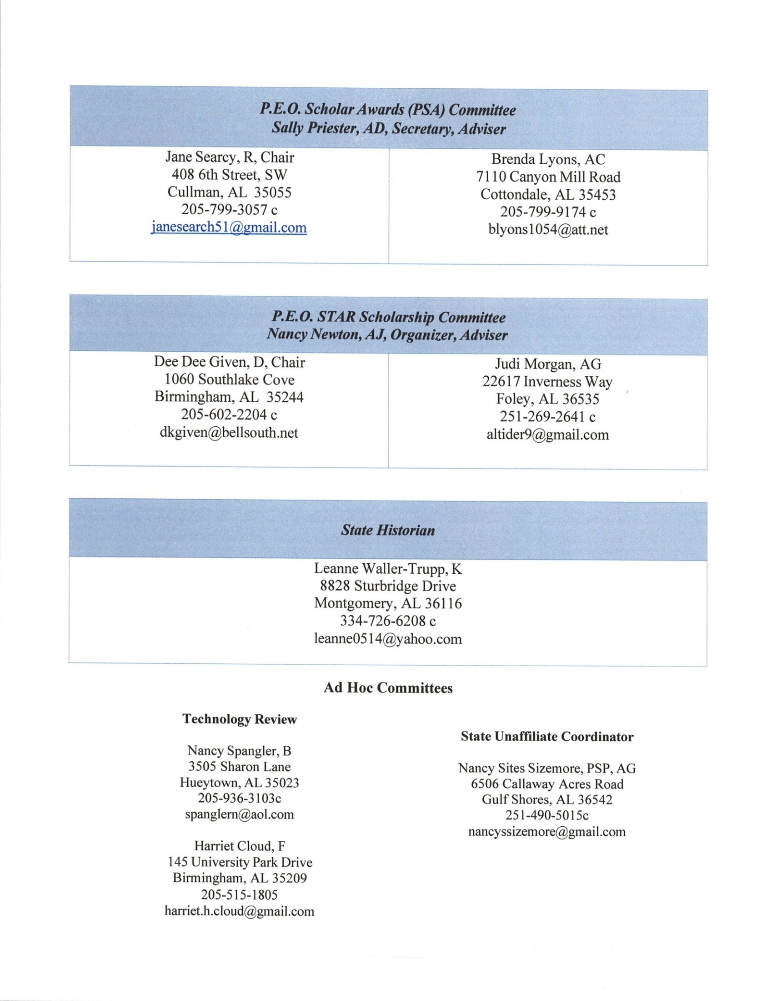



ALABAMA STATE CHAPTER GOALS

2025-2026

- Envision the Dream in P.E.O. Chapter Vitality by:

      - Ensure officers fully understand their responsibilities by having them attend one of the local chapter officer ZOOM training sessions and extend invitation to other chapter members.

      - Encourage sisters to say “YES” to chapter leadership roles with monthly invitation for Observation Shadowing of each officer during business meetings.

- Embrace your Sparkle in P.E.O. by:

    - Share P.E.O. philanthropy information with others by networking with local agencies and/or participating in College Fair Day if applicable.

    - Energize Joy and Excitement by hosting a minimum of 4 social events: one with 1-2 other chapters; one with BILS and 2 “Girls Just Want to Have Fun” socials with chapter sisters.

- Shine Bright in P.E.O. by:

  - Increase membership with at least two new sisters by initiation, transfer in, or reinstatement.

  - Participate in the Alabama State-Wide P.E.O. Day of Service.

ALABAMA STATE CHAPTER
OF THE P.E.O. SISTERHOOD

BYLAWS & STANDING RULES

April 26, 2025

BYLAWS

ARTICLE I -- CONVENTION OF ALABAMA STATE CHAPTER

Section 1—MEMBERS. The Convention of Alabama State Chapter shall consist of the following active members, when present and registered:
    - The executive board
    - Past presidents of the state chapter
    - Resident past presidents of International Chapter
    - Two delegates from each local chapter, the president being a delegate when feasible
    - Chair of the Amendments and Recommendations Committee
    - Chair of the Nominating Committee
    - Chair of the Finance Committee
    - Chair of the Membership Committee
    - Chair of the Alabama Cottey College Scholarship and Recruitment Committee
    - Chair of the P.E.O. Educational Loan Fund Committee
    - Chair of the P.E.O. International Peace Scholarship Committee
    - Chair of the P.E.O. Program for Continuing Education Committee
    - Chair of the P.E.O. Scholar Awards Committee
    - Chair of the P.E.O. STAR Scholarship Committee
    - Historian

Section 2—TIME AND PLACE/FORMAT. The Convention of the Alabama State Chapter shall be held annually in April or May, dates and place to be proposed by the convention chair and hostess chapters with final approval by the executive board. If determined by the executive board and approved by the Executive Board of International Chapter, convention may be conducted through the use of internet meeting services.

Section 3—HOSTESS CHAPTERS. The local chapters, grouped geographically by the executive board, shall arrange for housing and meals for the convention of the state chapter. No chapter shall be asked to serve as hostess for the convention of state chapter until five years after organization.

Section 4—REPORTS. Within one month following convention, delegates shall make a report of convention business to their respective chapters.

Section 5—FORMAL ACTION. Any item passed by Convention of Alabama State Chapter shall become effective, unless otherwise ordered at close of the convention and shall be implemented by local chapters upon receipt of the PROCEEDINGS of Alabama State Chapter.

ARTICLE II -- REPRESENTATION IN INTERNATIONAL CONVENTION

Section 1—DELEGATES. Delegates to Convention of International Chapter shall be chosen in rotation from geographical groups of seven local chapters or major fraction thereof. Grouping of local chapters for representation in Convention of International Chapter shall be arranged by the executive board, and these groupings shall be printed annually in the convention proceedings.

Section 2—NOMINATION AND ELECTION OF DELEGATES. Local chapters entitled to representation in Convention of International Chapter shall nominate a delegate and an alternate at the time of the annual election by or at the first regular meeting in March. Names of the nominees for delegates shall be submitted as required by International Chapter and presented to the following convention of the state chapter for election. Only those nominees who are members of that convention or of any previous convention of the state chapter shall be eligible.

Section 3—PAST PRESIDENTS OF THE STATE CHAPTER. Designation of the past presidents of the state chapter and their alternates entitled to housing and meals, to be paid for by International Chapter, at the Convention of International Chapter shall be made by those past presidents in attendance at convention of the state chapter preceding the Convention of International Chapter.

Section 4—VACANCY IN DELEGATION. In case of a vacancy, the president of the state chapter shall appoint as delegate: First, the nominee for alternate, elected by the local chapter; second, another member of the chapter entitled to representation; third, a member from another chapter in the group; fourth, a member from the state chapter at large. In case of a vacancy in the representation of past presidents entitled to housing and meals, the president shall appoint an alternate designated by the past presidents’ group.

Section 5—REPORTS. The Executive Board will prepare a report to be distributed to the local chapters in writing, electronically, or through another medium accessible to the local chapter.

ARTICLE III -- NOMINATION AND ELECTION OF OFFICERS

Section 1—ELIGIBILITY. Any member of convention who has been duly elected and installed and served at least one year as president of a local chapter shall be eligible for election to an office in the state chapter. The duties of elected officers of a state chapter are of sufficient importance to require their presence in the state during their terms of office.

Section 2—SEQUENCE OF OFFICERS. The sequence of state chapter officers shall be president, vice president, organizer, treasurer, and secretary.

Section 3—NOMINATION OF OFFICERS. A nominating committee of three members shall be appointed by the incoming president, with the approval of the executive board. The Chair shall be a recent Past State President and the other two members shall be selected from different geographical areas of the state.
At the convention of the state chapter, the committee shall present the name of one nominee for each office. Further nominations may be made from the floor for each office preceding the elective ballot for that office. Prior to nomination, all nominees shall have consented to serve if elected. The report of the nominating committee shall be given preceding the close of the first session of convention.

Section 4—ELECTION OF OFFICERS. Election of officers shall be by written or electronic ballot. If there are no further nominations from the floor for each office called for in sequence, by general consent, the ballot may be dispensed with and the vote taken for the ticket viva voce. If there are nominations from the floor for one or more offices, separate elective ballots shall be taken. A majority of votes cast shall elect.

ARTICLE IV -- SPECIAL DUTIES OF STATE OFFICERS

The following duties are in addition to those listed in the Constitution, Part II, Article VIII and in the Instructions to Officers of State Chapter.

Section 1—PRESIDENT. The duties of the president shall be as follows:
- To appoint necessary members to the following committees at the beginning of her term of office and to fill any vacancies, with the approval of the executive board:
  - A member to the Amendments and Recommendations Committee
  - A member to the Finance Committee
  - A member to the Alabama Cottey College Scholarship and Recruitment Committee
  - A member to the P.E.O. Educational Loan Fund Committee
  - A member to the P.E.O. International Peace Scholarship Committee
  - A member to the P.E.O. Program for Continuing Education Committee
  - A member to the P.E.O. Scholar Awards Committee
  - A member to the P.E.O. STAR Scholarship Committee
  - A Historian
  - A Nominating Committee of three members
  - An Auditing Committee
- To appoint such special committees as may be authorized by the executive board or a convention of the state chapter.
- To serve as an ex-officio member, without vote, of all standing committees, except the Nominating Committee.
- To provide information on various subjects to local chapters and Past State Presidents periodically throughout the year.
- To proofread the proceedings of convention and bylaws and standing rules of the state chapter following the expiration of her term of office.
- To act as Chair of the Alabama delegation to Convention of International Chapter.

Section 2—VICE PRESIDENT. The duties of the vice president shall be as follows:
- To serve as adviser to the Alabama Cottey College Scholarship and Recruitment Committee.
- To serve as ex-officio member, without vote, of the Finance Committee.

Section 3—ORGANIZER. The duties of the organizer shall be as follows:
- To visit, or direct her proxy to visit, those chapters scheduled for visits, giving the chapters at least thirty days’ notice.
- To serve as contact person for P.E.O. Groups and Reciprocity Groups.
- To serve as adviser to the Membership Committee.
- To serve as adviser to the P.E.O. STAR Scholarship Committee.

Section 4—TREASURER. The duties of the treasurer shall be as follows:
- To provide the Finance Committee with the information necessary for its work.
- To serve as ex-officio member, without vote, of the Finance Committee.
- To have the books of the treasurer audited at the end of the fiscal year.
- To serve as adviser to the P.E.O. Educational Loan Fund and P.E.O. Program for Continuing Education Committees.

Section 5—SECRETARY. The duties of the secretary shall be as follows:
- To inspect local chapter yearbooks and send a copy of the written report to the organizer for distribution to the chapters.
- To review amended local chapter bylaws and standing rules and forward appropriate comments to the president of the local chapter.
- To prepare a display of yearbooks at convention.
- To have the minutes of convention of state chapter approved by the president who presided at the convention before the minutes are printed in the proceedings.
- To have the proceedings of convention and the current bylaws and standing rules of the state chapter compiled and printed within three months following convention.
- To furnish electronic copies of the Proceedings and Bylaws and Standing Rules of Alabama State Chapter to the P.E.O. Executive Office as directed, the executive board of the state chapter, members of the Amendments and Recommendations Committee, members of the Finance Committee, the Historian, and the Alabama P.E.O. website. Submission to the P.E.O. Executive Office shall include two PDF files: the proceedings including the bylaws and standing rules, and a separate, “stand-alone” bylaws and standing rules document. To furnish hard copies to the executive board members, the immediate PSP, and those PSPs without access to email.
- To notify local chapters entitled to representation in Convention of International Chapter by November 1 of the year prior to the convention.
- To serve as adviser to the P.E.O. International Peace Scholarship and Scholar Awards Committees.

ARTICLE V -- FINANCE

Section 1—DUES. The annual dues of Alabama State Chapter shall be fifty-one dollars ($51.00) per active member, which shall be allocated as follows: Thirty-six dollars ($36.00) for International Chapter dues, which shall include six dollars ($6.00) for Cottey College; and fifteen dollars ($15.00) for state chapter dues.

Section 2—CONVENTION FEES. Each local chapter shall send annually with the dues the following fees for the State Convention Fund.
- A convention fee of three dollars ($3.00) per active chapter member.
- A registration fee of fifty dollars ($50.00) per local chapter.

Section 3—STATE RESERVE FUND.
- Establishment. Alabama State Chapter shall establish and maintain a fund to be known as the State Reserve Fund.
- Funding. Initial funding shall be by transfer from the Alabama State Chapter General Fund. Initial funding and additional transfers in or out shall be recommended by the Finance Committee and approved by vote of the members of convention of Alabama State Chapter.
- Requirements. The fund shall be administered by the treasurer of Alabama State Chapter at the direction of the executive board.
- Purpose. The purpose of the State Reserve Fund is to be a savings fund. The goal is to maintain a minimum balance equivalent to one year’s operating expenses of the Alabama State Chapter.

Section 4—STATE CONVENTION FUND.
- Establishment. Alabama State Chapter shall establish and maintain a State Convention Fund for the purpose of paying those expenses incurred to conduct the annual Convention of Alabama State Chapter.
- Funding. The State Convention Fund shall be funded according to ARTICLE V FINANCE, Section 2 – CONVENTION FEES. Transfers in or out shall be recommended by the Finance Committee and approved by vote of the members of convention of Alabama State Chapter.
- Requirements. The fund shall be administered by the treasurer of Alabama State Chapter at the direction of the executive board.
- Purpose. The purpose of the State Convention Fund is to eliminate the need of hostess chapters raising funds to pay for costs of convention.

Section 5—CONVENTION OF STATE CHAPTER.
A. The state chapter shall pay the expenses of convention from the State Convention Fund in accordance with the State of Alabama Executive Board Duties, Guidelines and Policies.
1. An annual allocation shall be made to the hostess chapters’ convention account to assist with expenses incurred for the ensuing convention.
i. Any surplus in the account shall be returned to the State Convention Fund by the hostess chapters.
ii. Any deficit incurred in the account will be repaid to the State Convention Fund by the hostess chapters.

B. Hostess chapters shall send their estimated costs to the executive board.

C. Each local chapter shall pay the travel, housing, and meals of their delegates.

Section 6—CONVENTION OF INTERNATIONAL CHAPTER. The state chapter shall pay the registration fee and the transportation expense based on the most economical method of travel to the Convention of International Chapter of its president, vice president or her alternate, and the local chapter delegates. The state chapter shall pay the transportation expense of the immediate past president of the state chapter based on the most economical method of travel provided she has not attended a previous Convention of International Chapter at state expense. Past presidents of the state chapter attending the Convention of International Chapter (whether or not they are entitled to housing and meals) shall pay their own registration fee and travel expenses. The state chapter will incur the cost of housing, at a half-room rate, when it is necessary for entitled members of convention to arrive the day before the start of convention activities. The state chapter will incur the cost of a Credentials Dinner at the Convention of International Chapter (CIC) to be organized by the state president, and attended by state delegates, entitled PSPs, and state officers attending as delegates. Others may attend the dinner at their own expense.
The state chapter will pay incidental expenses incurred by entitled PSPs, delegates, and state officers attending CIC as delegates. Reimbursements shall be made in accordance with the State of Alabama Executive Board Duties, Guidelines and Policies and will be made upon submission of receipts or other documentation within six weeks of attending Convention of International Chapter.

Section 7—EXECUTIVE BOARD AND COMMITTEES. Members of the Executive Board of
Alabama State Chapter and standing committees, when traveling on official business, shall be paid for necessary housing unless otherwise provided, and for traveling expense by car at a rate approved by the Executive Board of Alabama State Chapter that closely conforms to the rate paid by International Chapter or a sum not to exceed tourist class air fare.
Office expenses as authorized by the executive board shall be paid from the general fund and shall be reimbursed only by documented receipts submitted within three months of the date they were incurred.

ARTICLE VI -- STANDING COMMITTEES

Section 1—AMENDMENTS AND RECOMMENDATIONS.
- Appointment. The Amendments and Recommendations Committee shall consist of three members, each of whom shall serve three years. One member shall be a past president of the Alabama State Chapter. One member shall be appointed each year by the incoming president with approval of the executive board. The senior member in years of service shall be Chair. In case of the appointment of an entirely new committee, the president shall designate the Chair, second and third members.
- Duties. The duties of this committee shall be as follows:
  - To consider all amendments, recommendations and resolutions to come before convention of the state chapter; put such proposals into correct parliamentary form; and present same to convention.
  - To send a copy of the proposed amendments, recommendations and resolutions at least thirty days before convention of the state chapter to the following: local chapters, members of the executive board, members of all standing committees and past presidents of state chapter.

Section 2—FINANCE.
- Appointment. The committee on finance shall consist of three members, each of whom shall serve three years. One member shall be a past president of the Alabama State Chapter. One member shall be appointed each year by the incoming president with approval of the executive board. The senior member in years of service shall be chair. In case of the appointment of an entirely new committee, the president shall designate the chair, second and third members. The vice president and treasurer of the state chapter shall be ex-officio members, without vote, of this committee.
- Duties. The duties of this committee shall be as follows:
  - To become familiar with the finances of the state chapter and to consult and advise on financial matters with the executive board.
  - To coordinate with the executive board in preparing a budget for the state chapter for the ensuing year, and to present this budget for consideration at convention of the state chapter. A copy of this budget shall be placed in the kits of members of convention.
  - To recommend any necessary transfer of funds.

Section 3—HISTORIAN.
- Appointment. The committee on history shall consist of one member appointed each year by the incoming president with approval of the executive board. She shall be a member of a chapter in the city where the convention of state chapter is to be held, when feasible.
- Duties. The duties of this committee shall be as follows:
  - To collect and record data relative to P.E.O. in Alabama.
  - To compile information from local chapter presidents’ letters.
  - To present a summary of letters and data at each Convention of the Alabama State Chapter.
  - To serve as custodian of memorabilia which the historian and executive board deem advisable to be retained by the state chapter.

Section 4—ALABAMA COTTEY COLLEGE SCHOLARSHIP AND RECRUITMENT.
- Appointment. The committee of Alabama Cottey College Scholarship and Recruitment shall consist of three members, each of whom shall serve three years and each selected from different geographical areas of the state. One member shall be appointed each year by the incoming president with approval of the executive board. The senior member in years of service shall be chair. In case of the appointment of an entirely new committee, the president shall designate the chair, second and third members. The vice president shall be the adviser.
- Duties. The duties of the committee shall be as follows:
  - To promote Cottey College statewide.
  - To provide Cottey College information to local chapters.
  - To award scholarships when funds are available as determined by the executive board by March 1 of each year.
  - To renew the scholarships for a second, third and fourth year upon application by the students.
  - To prepare a display and provide a speaker for convention of state chapter.
  - To report annually to the convention of state chapter.

Section 5—NOMINATING. (See Article III, Section 3)

Section 6—MEMBERSHIP.
- Appointment. The committee on membership shall consist of four members, each of whom shall serve four years. One member shall be appointed each year by the incoming president of state chapter with the approval of the executive board. The senior member in years of service shall be chair. In case of the appointment of more than one new member the president shall designate the chair, second, third and fourth and terms of the members. The organizer shall serve as the adviser to the committee.
- Duties. The duties of this committee shall be as follows:
  - To promote membership statewide.
  - To provide membership guidance to local chapters.
  - To prepare a membership display for state convention.
  - To assist the organizer with membership issues.
  - To report annually to the convention of state chapter.

Section 7—PHILANTHROPIES. P.E.O. Educational Loan Fund, P.E.O. International Peace Scholarship, P.E.O. Program for Continuing Education, P.E.O. Scholar Awards, and P.E.O. STAR Scholarship.
- Appointment. Each committee shall consist of two members, each of whom shall serve two years. One member shall be appointed each year by the incoming president of state chapter with the approval of the executive board. The senior member in years of service shall serve as chair. In case of the appointment of an entirely new committee, the president shall designate the chair and second member.
- Advisers. The treasurer shall serve as adviser to the P.E.O. Educational Loan Fund and the P.E.O. Program for Continuing Education Committees; the secretary shall serve as adviser to the P.E.O. International Peace Scholarship and the P.E.O. Scholar Awards Committees; and the organizer shall serve as adviser to the P.E.O. STAR Scholarship Committee.
- Duties. The duties of these committees shall be as follows:
  - To promote the philanthropies statewide.
- To provide philanthropy guidance to the local chapters.
- To prepare a display and provide a speaker for convention of state chapter.
- To report annually to the convention of state chapter.

ARTICLE VII -- ALABAMA COTTEY COLLEGE SCHOLARSHIP

Section 1—ESTABLISHING ACT. A fund to be known as the Alabama Cottey College Scholarship Fund shall be maintained for the purpose of granting scholarships to Cottey College.

Section 2—SCHOLARSHIP REQUIREMENTS. Scholarships shall be granted to a resident of Alabama on the basis of character, scholastic standing, recommendation of the Cottey College Admissions Office and the approval of the Alabama Cottey College Scholarship and Recruitment Committee.

Section 3—FUNDING. The scholarship fund shall be maintained by gifts and bequests for the primary purpose of awarding scholarships to young women who are residents of Alabama desiring to attend Cottey College. The Alabama Cottey College Scholarship Fund shall be banked in a separate account; all interest accrued shall remain in said account.

Section 4—GRANTS. Women who are Alabama residents and interested in attending Cottey
College may apply for a grant toward transportation expenses for participation in an official Cottey
Admissions visit. The total of transportation grants will be less than ten percent of the unencumbered balance in the Alabama Cottey College Scholarship Fund in any one year. Administration of grants will be the responsibility of the Alabama State Cottey College Scholarship and Recruitment Committee and approved by the Executive Board of Alabama State Chapter.

ARTICLE VIII -- ORGANIZATION AND OFFICIAL VISITS

Section 1—ORGANIZATION OF NEW CHAPTERS.
- Requirements. The following requirements are in addition to those listed in the Constitution, Part III, Article I.
  - After a request to organize a new chapter has been received and consent given by the organizer, the prospective chapter shall have eight scheduled meetings before organization. Minutes of the meetings shall be kept and a copy sent to the organizer.
  - No new chapter shall be organized within thirty days of the convention of the state chapter.
- Charter Initiates. Each charter initiate shall be recommended by a letter to the organizer of the state chapter from three active members of the sisterhood.

Section 2—OFFICIAL VISITS TO LOCAL CHAPTERS. Official visits by the organizer shall be quinquennial. However, a new or reorganized chapter shall be visited annually for the first three years. Any chapter may be visited at the discretion of the Executive Board of Alabama State Chapter, or any chapter may request a visit during an unscheduled year.
The local chapter shall assume responsibility for housing and meals of the organizer or her proxy during her official visit.

ARTICLE IX -- SPECIAL DUTIES OF LOCAL CHAPTER OFFICERS

The following duties are in addition to those listed in the Constitution, Part III, Article V and in the Instructions to Officers of Local Chapters.

Section 1—PRESIDENT. The duties of the president shall be as follows:
- To write an annual letter and report to the president of the state chapter informing her of the activities and status of the chapter. The letter and report shall be read and approved at a chapter meeting in February and mailed before March 1. A copy of this letter and report shall be retained in the local chapter president’s box and copies shall be sent to absent members.
- To coordinate with elected chapter delegates to state convention so that any vacancy will be immediately filled by an alternate delegate. In the event that no delegate attends convention, the chapter shall incur a visit by a state officer, at the chapter’s expense.
- To coordinate with elected delegate to Convention of International Chapter, ensuring that a vacancy will be immediately filled by the alternate delegate. A chapter failing to provide either the elected or alternate delegate will be required to reimburse the state for expenses incurred on her behalf.
- To ensure the delivery of the chapter yearbook as designated by the state board.

Section 2—RECORDING SECRETARY. The duty of the recording secretary shall be as follows:
- To send, in March, to the secretary of the state chapter a copy of the chapter bylaws and standing rules, if they have been amended during the fiscal year.

ARTICLE X -- SPECIAL DUTIES OF LOCAL CHAPTERS

Section 1—REPORTS. The local chapter membership and philanthropy chairs shall submit annual reports by March 10.

Section 2—PHILANTHROPY COMMITTEES. The local chapter philanthropy chairs shall maintain permanent files.

ARTICLE XI -- RECIPROCITY GROUPS

Section 1—PURPOSE. Reciprocity Groups may be formed as stated in the Constitution, Part III, Article XIII.

Section 2—SUPERVISION. Each group so formed shall be under the supervision of the organizer of the state chapter.

Section 3—REPORTS. Names and addresses of newly elected officers and contact person shall be submitted as required by International Chapter immediately following election.
Each reciprocity group shall send to the organizer of the state chapter the following:
- By March 10, the annual financial report required by International Chapter for the fiscal year March 1 through February 28/29; and
- A copy of the bylaws if amended during the year. If the bylaws were not amended, the organizer shall be so notified.

ARTICLE XII -- P.E.O. GROUPS

Section 1—ESTABLISHMENT. P.E.O. Groups may be formed as stated in the Constitution, Part III, Article XIV.

Section 2—SUPERVISION. Each group so formed shall be under the supervision of the organizer of the state chapter.

Section 3—REPORTS. Names and addresses of newly elected officers and contact person shall be submitted as required by International Chapter immediately following election.
Each P.E.O. Group shall send to the organizer of the state chapter the following:
- By March 10, the financial report required by International Chapter for the fiscal year March 1 through February 28/29;
- A copy of the bylaws if amended during the year. If the bylaws were not amended, the organizer shall be so notified; and
- Copy of the yearbook and/or current program.

ARTICLE XIII -- PARLIAMENTARY AUTHORITY

The rules contained in the current edition of Robert’s Rules of Order Newly Revised shall govern all meetings in matters not covered by these bylaws.

ARTICLE XIV -- GOVERNING LAW

Section 1. These bylaws shall comply with governmental laws applicable to the operation of the state chapter.

ARTICLE XV -- AMENDMENTS

Section 1—PROCEDURE. Amendments to the Bylaws of Alabama State Chapter shall be proposed only by local chapters, the executive board or standing committees of the state chapter and shall be submitted in writing to the Chair of the Amendments and Recommendations Committee and to the president of Alabama State Chapter by January 20. Local chapters desiring to submit an amendment must have that proposal approved by a two-thirds vote at a regular meeting provided the amendment was submitted in writing at a previous regular meeting and all absent resident members notified that a vote will be taken at the next regular meeting.

Section 2—VOTE REQUIRED. These bylaws may be amended by a two-thirds vote of the members voting in Convention of Alabama State Chapter, provided that copies of the proposed amendments shall have been sent at least thirty days before convention to those named in Article VI, Section 1 of these bylaws.

STANDING RULES

1. The executive board of the state chapter shall determine the requirements for chapter yearbooks and shall inform the chapters of those requirements following the mid-year meeting.
2. Workshops for local chapters may be scheduled at the discretion of the executive board.
3. The immediate past president of the state chapter shall be responsible for the Celebration of Life at convention of state chapter.
4. The name of a member whose death occurs less than ten (10) days prior to convention shall appear on the Memorial Roll at convention the following year.
5. Both the American and Canadian flags shall be given a prominent place in convention of state chapter.
6. The chair of convention shall, by one month after convention, submit a complete financial report to the outgoing state president, the incoming state president, the convention Chair and chapter convention chairs for the next two conventions.
7. All committees and officers of state chapter shall obtain approval from the president of state chapter before sending any form letters.
8. All P.E.O. philanthropy monies shall be sent to the state treasurer by March 1 each year.
9. Amendments to the Standing Rules of Alabama State Chapter shall be proposed only by local chapters, the executive board or standing committees of the state chapter and shall be submitted in writing to the chair of the Amendments and Recommendations Committee and to the president of Alabama State Chapter by January 20. Such proposed amendments shall be adopted by a majority vote of members present and voting in Convention of Alabama State Chapter, provided that copies of the proposed amendments shall have been sent at least thirty days before convention to those named in Article VI, Section 1 of these bylaws.

