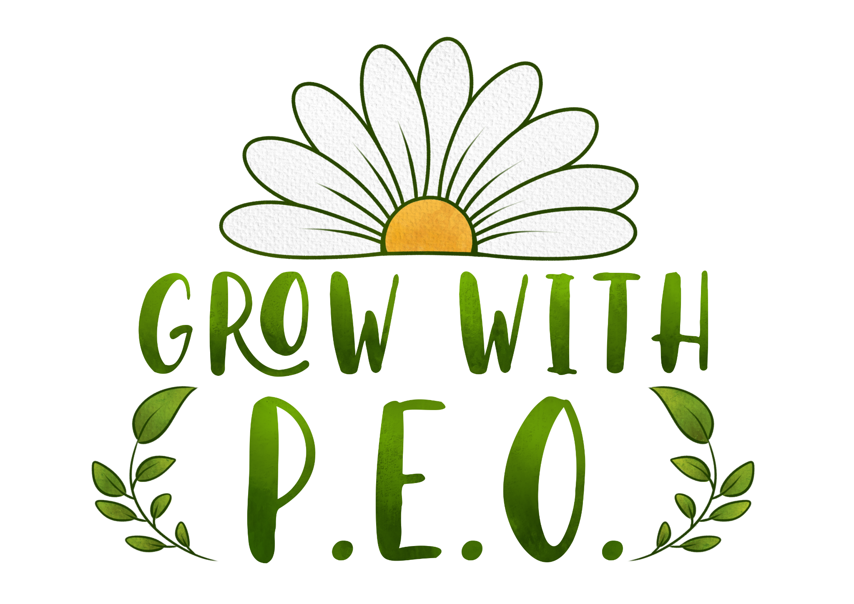
P.E.O. Alabama State Chapter Officers
And State Committees
2026-2027
EXECUTIVE BOARD OFFICERS
President  Paige McCormick, AC  28 Cherokee Road  Tuscaloosa, AL 35404  205-344-3096 c  peopaige@gmail.com  Board Buddies: E, H, O, W, AB, AF, AI, AJ | Vice President  Nancy Newton, AJ  106 Callen Drive  Madison, AL 35756  719-428-9360 c  nancynewton.peo@gmail.com  Board Buddies: A, B, D, F, K, R, T, AG | Organizer  Cheryl (Chery) Williams, AG 10790 Coleman Lane  Elberta, AL 36530  256-506-0563 c  cherypeo@gmail.com  Board Buddies: I, J, L, S, Y, AA, AD, AH, AK
Treasurer  Sally Martin Priester, AD  59 Cypress Grove Lane,  SW Huntsville, AL 35824  607-280-5076 c  sallypriester.peo@gmail.com  Board Buddies: C, G, N, Q, X, Z, AC, AM, AP |  | Secretary  Nancy Spangler, B  3505 Sharon Lane  Hueytown, AL 35023  (205) 936-3013 c  peonancys@gmail.com  Board Buddies: M, P, U, V, AE, AL, AN, AO

Alabama Cottey College Scholarship & Recruitment Committee
Nancy Newton, AJ, Vice President, Adviser
Cynthia Lumpkin, AH, Chair  912 Canterbury Drive  Dothan, AL 36305  334-790-1643 c  cynthia.tippi@gmail.com | Sarah Allen, AL  134 Lewis Mountain Road New Market, AL 35761  256-648-1978 c  sallen91711@gmail.com | Kim DeRamus, AM  812 Fish Camp Road  Chelsea, AL 35043  941-962-1067 c  mymarwood@yahoo.com

Amendments & Recommendations Committee
Sonya Leeds, AH, Chair  108 Lamar Lane  Dothan, AL 36301  402-916-0551 c  sonya.leeds@gmail.com | Shirley Paramore, PSP, V  303 Lakes Drive  Enterprise, AL 36330  205-837-3644 c  sparamore21@gmail.com | Karen Sargent, AL  120 High Coach Way  Madison, AL 35758-7326  256-603-1289 c  prairiequilter2001@gmail.com

Finance Committee
Carol Sue Lewis, G, Chair  70 Grove Park Loop  Wetumpka, AL 36093  334-799-4007 c  csr9516@yahoo.com | Betty Smith, PSP, V  156 Wood Place Court  Ozark, AL 36360  334-790-4817 c  jamiesmith652@centurytel.net | Katherine Penton, H  120 Batre Lane  Mobile, AL 36608  404-992-7538 c  katherine.penton@gmail.com

Membership Committee
Cheryl (Chery) Williams, AG, Organizer, Adviser
Merrily Newton, AM, Chair  2645 O’Neal Circle  Birmingham, AL 35226  205-566-0937 c  mkjn2004@att.net | Lisa Vardaman, AF  106 Dendro Avenue Troy, AL 36081  334-268-8653 c  peo.lisavardaman@gmail.com | Carol Westbrook, PSP, D  2237 Savoy Street  Birmingham, AL 35226 205-401-5515 c  cdwest43@gmail.com | Amanda von Herrmann, M  9704 Welch Cir SE Huntsville, AL 35803  205-789-6392 c  avonherrmann@gmail.com

Nominating Committee
Paige McCormick, AC, President, Liaison
Elaine Bassett, PSP, AF, Chair  108 Deerfield Drive  Troy, AL 36081  (334) 372-7329 c  elaine.bassett.peo@gmail.com | Marian (Mame) Morgenstern, G  376 Willow Bend Dr  Wetumpka, AL 36093-1806  334-567-9083 h  334-303-3331 c  dandmmorgenstern@aol.com | Jennifer Macie, M  126 Given Cove  Laceys Spring, AL 35754  678-923-2639 c  jennifermacie@bellsouth.net

P.E.O. Educational Loan Fund (ELF) Committee
Sally Priester, AD, Treasurer, Adviser
Dawn Daly, E, Chair  3302 Heatherbrook Drive  Opelika, AL 36801  703-346-7919 c  daly.dawn@gmail.com | Martha Hocutt, I  5 Rosemont Dr  Tuscaloosa, AL 35401-5938  205-799-8207 c  mhocutt@uwa.edu

P.E.O. International Peace Scholarship (IPS) Committee
Nancy Spangler, B, Secretary, Adviser
Nancy Elliott, C, Chair  126 Florence Place  Mobile, AL 36607  813-833-0513 c  miznancy1@yahoo.com | Janice Curtis, AN  222 Jordan Lane  Florence AL 35630  256-710-3646 c  jcurtis0927@gmail.com

P.E.O. Program for Continuing Education (PCE) Committee
Sally Priester, AD, Treasurer, Adviser
Beth Beck, Z, Chair  235 Winter Ln  Madison, AL 35757-8203  256-651-7273 c  bethbeck1doghunter@gmail.com | Carole Worsham, AD  684 Wade Rd  Owens Cross Roads, AL 35763-9120  256-534-9109 c  cpw758@comcast.net

P.E.O. Scholar Awards (PSA) Committee
Nancy Spangler B, Secretary, Adviser
Brenda Lyons, AC, Chair  7110 Canyon Mill Rd  Cottondale, AL 35453-4626  205-799-9174 c  blyons1054@att.net | Kathy Strayer, R  2435 Alexander Dr  Tuscaloosa, AL 35405  205-454-2505 c  kbsophia@att.net

P.E.O. STAR Scholarship Committee
Cheryl (Chery) Williams, AG, Organizer, Adviser
Judi Morgan, AG, Chair  22617 Inverness Way  Foley, AL 36535  251-269-2641 c  altider9@gmail.com | Denise Williams, PSP, U  1401 Fairway Dr SE  Decatur, AL 35601-6525  225-772-1453 c  denise.williams.peo@gmail.com

State Historian
Leanne Waller-Trupp, K
8828 Sturbridge Drive
Montgomery, AL 36116
334-726-6208 c
leanne0514@yahoo.com

State Unaffiliate Coordinator | Ad Hoc Chapter Vitality Coach Committee
Nancy Sites Sizemore, PSP, AG  6506 Callaway Acres Rd  Gulf Shores, AL 36542  251-490-5015 c  nancyssizemore@gmail.com | Gayle Howell, PSP, AC, Chair  15318 Tierce Lake Rd  Northport, AL 35475-3813  205-242-5436 c  gaylepeo@aol.com  Shellyn Poole, F  Patty Piro, PSP, AL
Ad Hoc Committee to  Establish Alabama State Scholarship Fund | Ad Hoc Alabama State Chapter  P.E.O. History Committee
Cindy Fry, PSP, AD, Chair  22898 Cog Hill Dr  Athens, AL 35613  256-683-3890  cindyfrypeo@gmail.com  Kelli Weaver, AG  Nancy Sites Sizemore, PSP, AG  Jennifer Macie, M  Judy Wesson, L | Linda Kottmeyer, PSP, AM, Chair  2137 Brook Highland Ridge  Birmingham, AL 35242-5871  205-283-1670 c  linda.kottmeyer.peo@gmail.com  Cel Bailey, PSP, D  Leanne Waller-Trupp, K

